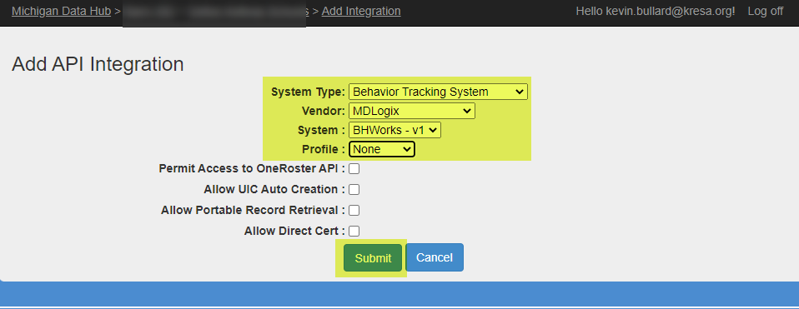
Steps to create the API Integration:
System Type: Behavior Tracking System
Vendor: MDLogix
System: BHWorks
Profile: None (Please note that the integration will not work if the Behavior Profile is selected here)
**Remaining options should all be left unchecked
Press Submit to create the integration.
PLEASE work directly with the support team at mdlogix on steps to securely share the API Key/ Secret.

