Solar Winds Helpdesk – How to create a query
Use this walkthrough to create a query in web helpdesk to view tickets assigned to you, in your location, by specific timeframes, status, etc.
Step 1:
Select Search Tickets and the Advanced Search tab

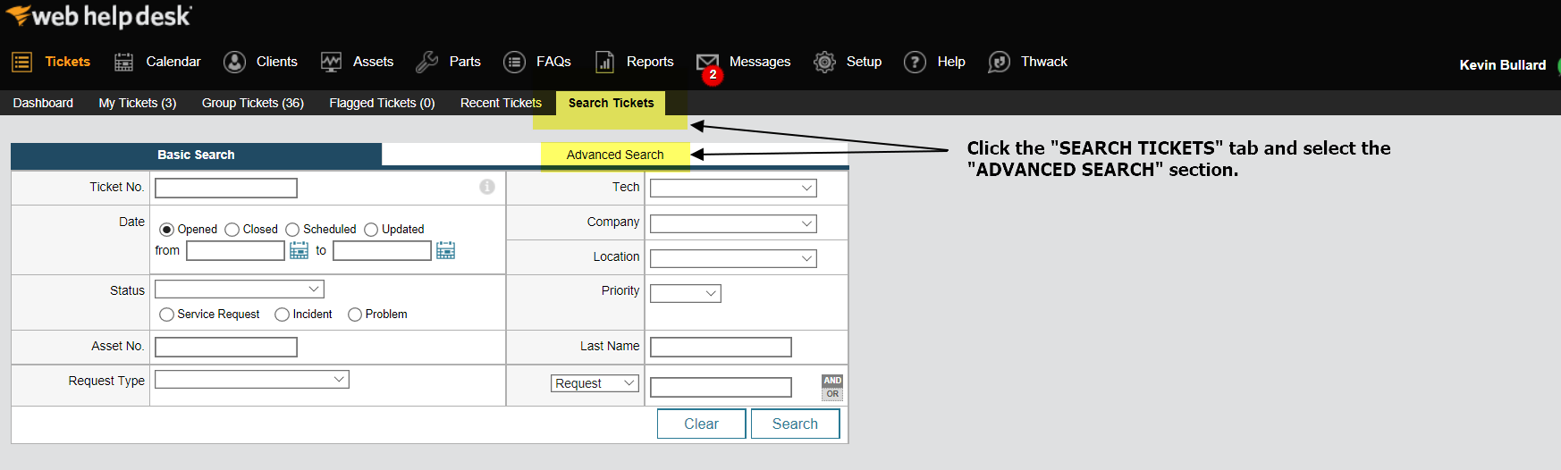

Step 2:
If modifying a current query, select the query. If you are creating a new query, leave this option blank.
- The minus button will delete any selected query in the pull-down menu
- Query criteria allows you to build queries based on specific fields such as status (open/closed), location (Oakland ISD/Kalamazoo RESA/etc..). you can also add additional parameters with the “add any of these conditions section”
- The Save query field is where you will add the name of the query. The “shared” button will share with ALL techs in the helpdesk system (currently all DHSS staff). If you wish to not share the query it will only be available under your account.
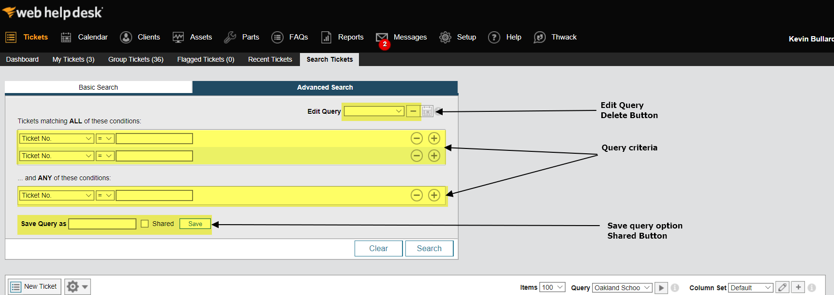

Step 3:
The example query below will provide all tickets that have a company (location) selected as Oakland Schools, status is open, and been opened within the last 15 business days.
- The query was saved as Sample Oakland
- Shared checkbox is selected (query will be available to ALL DHSS techs listed in web helpdesk)
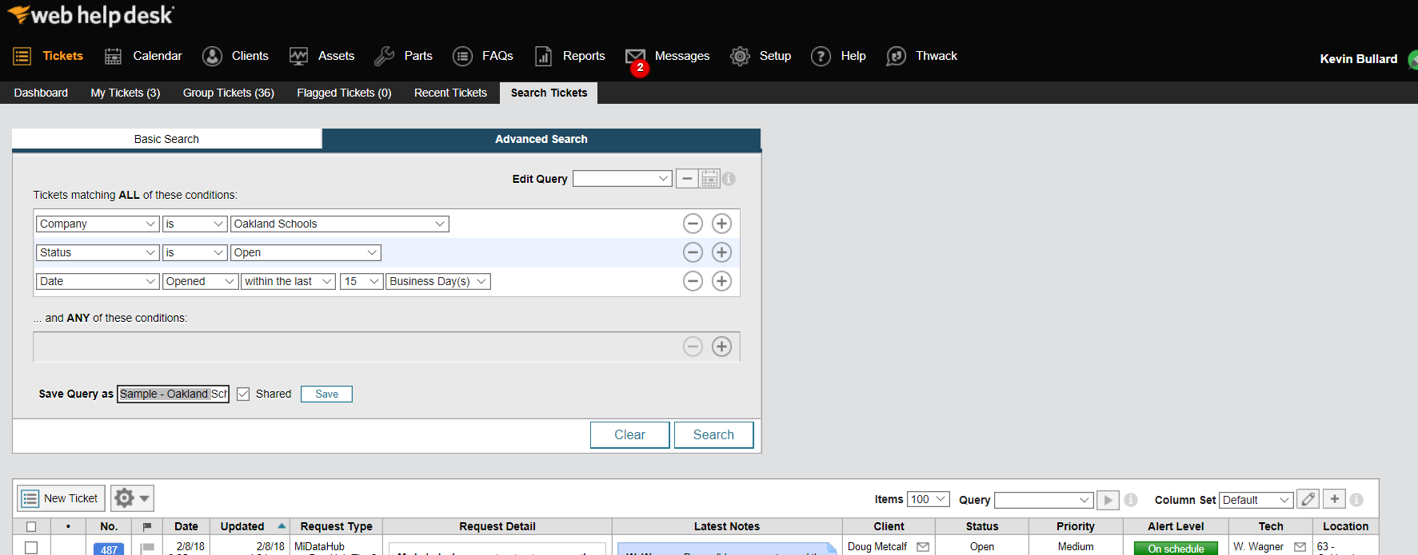
- Query results will be displayed below the query filters.

Step 4:
Click on Group Tickets and from the query pull down menu, select the query available to you.
- Your results from the query will be displayed
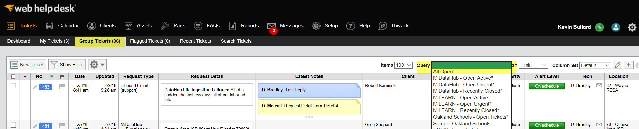
- If you would like to modify your query, select search tickets, and repeat the steps above.

If you have any questions while creating or after reviewing the query please contact the Data Hub support desk at support@midatahub.org.

