Request for UIC – Creation and Retrieval

Request for UIC – (obtain only)

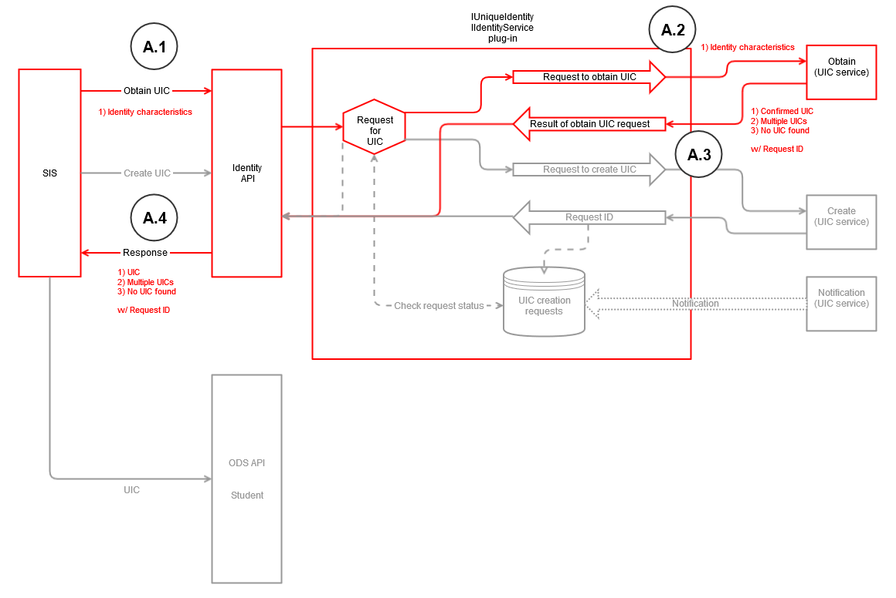

Scenario A – (Application seeks UIC from API)
- Application calls Identity API with Identity Characteristics to obtain UIC
- Request for UIC plugin calls Obtain service
- Obtain service returns Confirmed UIC, Near-Match UICs, or No UIC Found. Request ID is also returned.
- API returns result to the application (along with Request ID)

Request for UIC – (obtain or create)

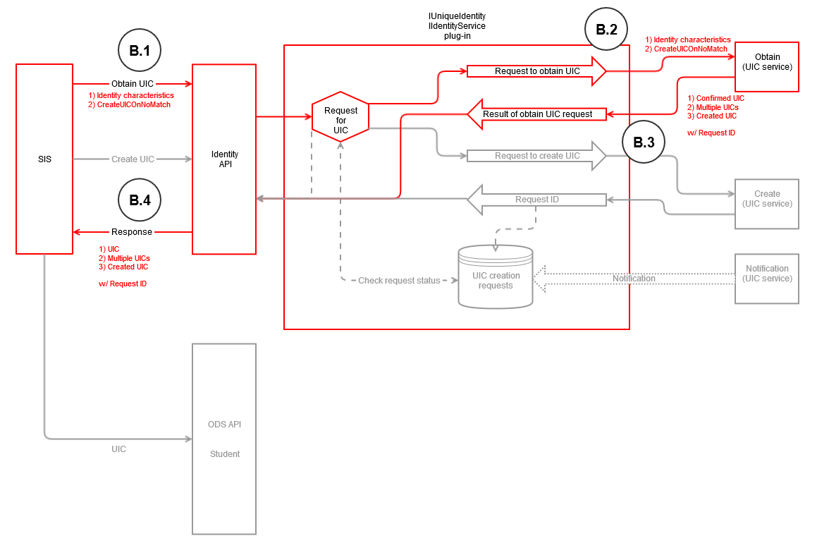

Scenario B – (SIS seeks UIC from API; has create-if-none-found privilege)
- SIS calls Identity API with 1) Identity Characteristics and 2) CreateUICOnNoMatch parameter to obtain UIC
- Request for UIC plugin calls Obtain service
- Obtain service returns Confirmed UIC, Near-Match UICs, or Created UIC (because no UIC was found). Request ID is also returned.
  - (If potential matches are presented, need to include a process where SIS confirms the selected match for PEPE)
- API returns result to the SIS (along with Request ID)

Request for UIC – (create)

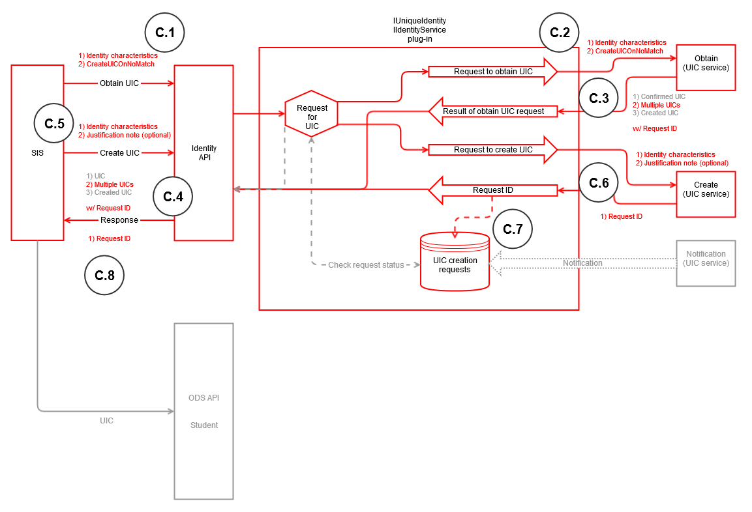

Scenario C – (SIS requests creation of UIC; no match found among multiple returned)
- SIS calls Identity API with 1) Identity Characteristics and 2) Create-if-none-found parameter to obtain UIC
- Request for UIC plugin calls Obtain service
- Obtain service returns Near-Match UICs
- API returns result to the SIS
- Because no match is found among the multiple UICs returned, SIS calls Identity API to create with Identity Characteristics to create a UIC
  - SIS is able to send back a text field with reason/justification for the creation request
- Create service returns a Request ID
- Request for UIC plugin logs the Request ID
- API returns result to the SIS with Request ID

Request for UIC – (check request status)

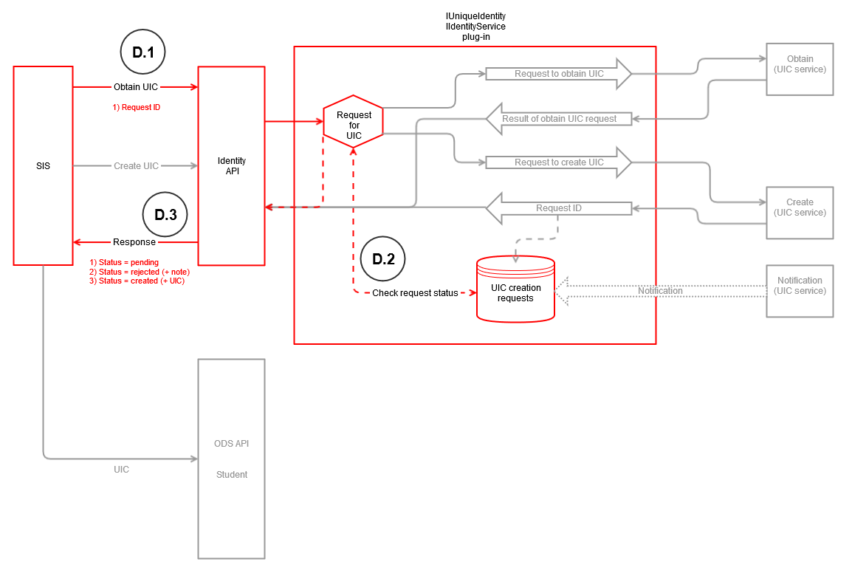

Scenario D – (SIS checks status of Request ID)
- SIS calls Identity API with Request ID to check status of create request
- Request for UIC plugin checks UIC Creation Requests DB with Request ID for status (Pending, Rejected + note, Created + UIC)
- API returns Request ID status to SIS (if status is 'Created,' the created UIC is returned to the SIS)
  - Approver notes may be provided if the request is denied or some other status applies

Request for UIC – (notification)

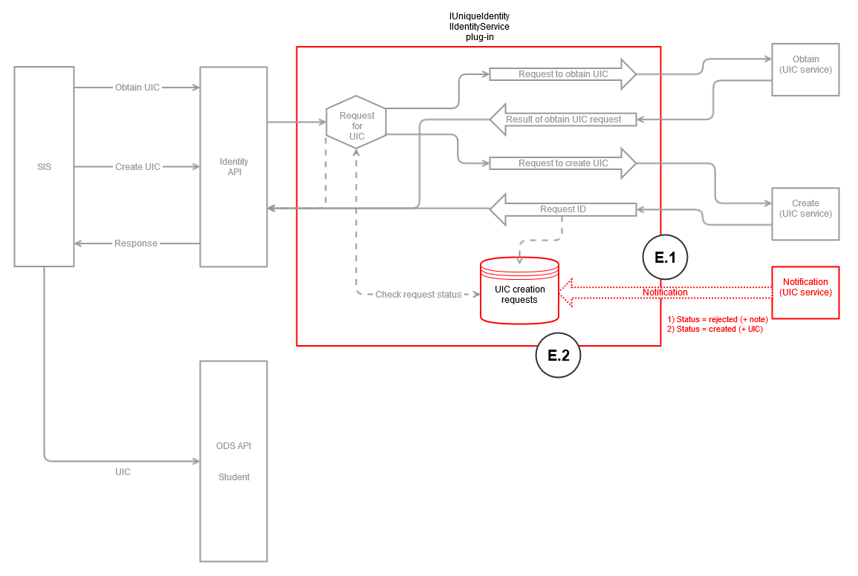

Scenario E – (UIC service sends notification)
- UIC service sends notification to Request for UIC plugin with status update of Request ID (along with possibly an approver note)
- Request for UIC plugin updates status of Request ID in UIC Creation Requests DB

Scenarios
Scenario A - (Application seeks UIC from API) | Scenario B - (SIS seeks UIC from API; has create-if-none-found privilege) | Scenario C - (SIS requests creation of UIC; no match found among multiple returned) | Scenario D - (SIS checks status of Request ID)
- Application calls Identity API with Identity Characteristics to obtain UIC  - Request for UIC plugin calls Obtain service  - Obtain service returns Confirmed UIC, Near-Match UICs, or No UIC Found. Request ID is also returned.  - API returns result to the application (along with Request ID) | - SIS calls Identity API with 1) Identity Characteristics and 2) CreateUICOnNoMatch parameter to obtain UIC  - Request for UIC plugin calls Obtain service  - Obtain service returns Confirmed UIC, Near-Match UICs, or Created UIC (because no UIC was found). Request ID is also returned.  - (If potential matches are presented, need to include a process where SIS confirms the selected match for PEPE)  - API returns result to the SIS (along with Request ID) | - SIS calls Identity API with 1) Identity Characteristics and 2) CreateUICOnNoMatch parameter to obtain UIC  - Request for UIC plugin calls Obtain service  - Obtain service returns Near-Match UICs  - API returns result to the SIS (along with Request ID)  - Because no match is found among the multiple UICs returned, SIS calls Identity API to create with Identity Characteristics to create a UIC  - SIS is able to send back a text field with reason/justification for the creation request  - Create service returns a Request ID  - Request for UIC plugin logs the Request ID  - API returns result to the SIS | - SIS calls Identity API with Request ID to check status of create request  - Request for UIC plugin checks UIC Creation Requests DB with Request ID for status (Pending, Rejected + note, Created + UIC)  - API returns Request ID status to SIS (if status is 'Created,' the created UIC is returned to the SIS)  - Approver notes may be provided if the request is denied or some other status applies

Upon creation of UIC:
- When a UIC is created via the Create service,
  - The UIC service notifies Request for UIC plugin of ‘Created’ status
  - The status of ‘Created’ is not relayed back to SIS automatically. SIS must check status with Request ID.
- When a UIC is created via the Obtain service, it is carried out real-time and the new UIC is returned in the response

SIS needs to:
- Store Request ID if Create UIC request has been submitted
- Poll per desired frequency with Request ID

