Using DataHub Active Directory Federation Services (ADFS)

as an OAuth 2 Authorization Server

Prerequisites
- An OAuth 2 capable client application (“Algebra Nation”) - hereafter referred to as "client app".
- An arbitrary (but agreed upon between ADFS and Algebra Nation) resource name for Algebra Nation.
  - "Resource" is used in the sense of an OAuth 2 Resource … the thing for which access permission is being given. This resource name will be transmitted in HTTP requests by Algebra Nation as required in OAuth 2 when redirecting users to an authorization server (ADFS), and will be stored by ADFS as the Identifier property of the Relying Party Trust that represents Algebra Nation.
  - A suggestion for resource name would be the Login URL for Algebra Nation (i.e., https://AlgebraNation.com/login).
- An arbitrary (but agreed upon between ADFS and Algebra Nation) Client ID value with which the client app will identify itself to ADFS in HTTP calls
  - This is a value that is required of all OAuth 2 clients, and so likely already exists (or is configurable) in Algebra Nation.
  - This Client ID should be a globally unique identifier (GUID), a name in the format 00001111-2222-3333-4444-555566667777
  - The preceding numbers are arbitrary, but should only include the following hexadecimal characters: 0 1 2 3 4 5 6 7 8 9 0 a b c d e f
  - Either the ADFS administrator or the client app administrator can create the Client ID The main requirement is that it be unique.
- The URI at which an OAuth 2 capable client application (“Algebra Nation”) accepts an Authorization Code (https://tools.ietf.org/html/rfc6749#section-1.3.1).
- The URI at which an OAuth 2 capable client application (“Algebra Nation”) accepts a Token.

Goal
The following procedure will configure single sign-on by delegating authentication to Active Directory when a user attempts to log in to Algebra Nation.

ADFS steps (for DataHub SSO team)
- Open the ADFS management console (found in the Admin Tools of the Active Directory Domain Controller or dedicated ADFS server). Click the Claims Provider Trusts node and ensure Active Directory appears as one of the entries in the Claims Provider Trust panel, and that Yes appears in the column Enabled.
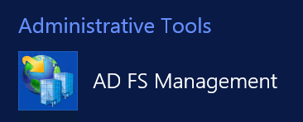

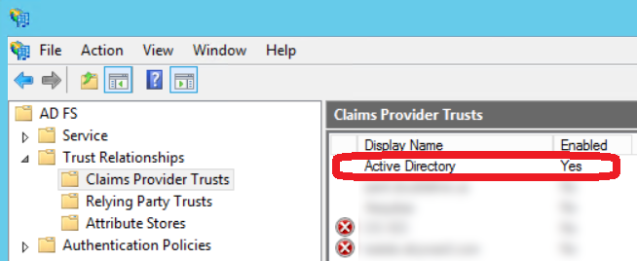

- Use Appendix "A" at the end of this document to configure Algebra Nation as a Relying Party Trust.
- On the ADFS Server, run the following command:
Add-AdfsClient
-Name "Algebra Nation"
-ClientId "11111111-2222-3333-4444-555566667777"
-RedirectUri @("https://web.algebranation.com/sso/mi")
-Description "OAuth 2.0 client for Algebra Nation-Michigan Datahub integration"
-LogoutUri "https://web.algebranation.com/sso/mi"

Parmeter | Purpose
Name | Friendly name to be displayed in the ADFS Management Console.
Client ID | The unique identifier agreed upon by DataHub and Algebra Nation that Algebra Nation will identify itself with when requesting an Authorization Code or Token from ADFS. This value may be exposed publiclly - it is a name, not a secrtet. This value is arbitrary … no meaning will be assumed other than it uniquely identifies Algebra Nation.
Redirect URI | One or more URL's to which Algebra Nation may request that ADFS send it an Authorization Code and/or Tokens. In OAuth 2, when a user wants to access Algebra Nation, it is expected the Algebra Nation will redirect the user's browser (with a HTTP 302 response) to ADFS's Autorization Endpoint accompanied by a Redirect URI … and after logging in at ADFS, the user will be redirected again to the Redirect URI provided by Algebra Nation, carrying the Authorization Code needed to this URI. ADFS will only redirect the logged in user back to Algebra Nation if the Redirect URI that ADFS receives match exactly (including any terminating slash characters)
Description | Long Text friendly description to be displayed in the ADFS Management Console.
LogoutUri | OPTIONAL: If Algebra Nation wants to be notified when a user logs out of ADFS, then Algebra Nation must provide a URI to which ADFS can send such notifications via HTTP. This communication could allow Algebra Nation to immediately invalidate any tokens related to this user, for example.

Example OAuth 2 Flow between Algebra Nation and ADFS (Data Hub)
The following is a step-by-step description of how the OAuth 2 Authorization Code Grant flow might happen:

- A user attempts to log in to Algebra Nation.
- Because Algebra Nation has indicated that it supports OAuth 2 Authorization Code Grant, it can be configured to redirect the user to the ADFS Authorization URL where the user will log in: https://[ADFSServerURL]/adfs/oauth2/authorize?response_type=code&client_id=ClientID&resource=https%3A%2F%2FAlgebraNation.com%2Flogin&redirect_uri=https%3A%2F%2FAlgebraNation.com%2FOurRedirectUri
Parmeter | Purpose
response_type | Always code. Tells ADFS that Algebra Nation wants back an Authorization Code after the user successfully authenticates with ADFS.
client_id | This is the Client ID, the public, unique identifier created to represent Algebra Nation to ADFS, as described earlier in this document.
resource | This is defined by Algebra Nation, but saved as the Identifier property of the Relying Party Trust created in ADFS to represent Algebra Nation.  Normally, in OAuth 2's standard flow, this would be the name of some data/documents/applications belonging to the user, but residing on a third party server, that the user will grant permissions to Algebra Nation to use.  But since we are creating an authentication (not an authorization) protocol, this should be an identifier that describes the Algebra Nation logon URL in the ADFS Relying Party like http://AlgebraNation.com/login.
redirect_uri | An HTTP endpoint that Algebra Nation provides in order to receive authorization tokens from the OAuth 2 authorization server (ADFS, in this case).

- ADFS compares the redirect_uri parameter to the list of Redirect URI's provided in the PowerShell command given earlier in the document. If the redirect_uri matches one of them, precisely, including any trailing slash that might be present, then the user is prompted to log in.
- The user logs in, then ADFS automatically redirects the user's browser to the redirect_uri issued by Algebra Nation, carrying with it a newly created Authentication Code.
- Algebra Nation uses the Authentication Code and requests a token from ADFS (note that the client secret isn't required, nor used, by ADFS - it can be included, but will be ignored):

POST /adfs/oauth2/token HTTP/1.1
Content-Type: application/x-www-form-urlencoded
Host: adfs.michigandatahub.mi.us This Host Name is provided by the data hub ADFS administrator to Algebra Nation

grant_type=authorization_code&client_id=ClientID&redirect_uri=http%3A%2F%2FAlgebraNation.com%2FgiveMeToken&code=authorizationCode

- As before, ADFS checks the redirect_uri against those provided in the ADFS PowerShell setup command, and if there is a match, ADFS sends a token to Algebra Nation at the Redirect URI given in the request. The token is defaulted to 1 hour expiration, too. In this case, though, Algebra Nation needs the token merely for authentication, and can provide authorization merely by verifying one of the provided user claims inside the JWT token.
- Algebra Nation receives the a JWT token (JSON Web Token) with claims of the user's identity inside (name, email) from ADFS/Active Directory.
- Algebra Nation can make any authorizations it would as if the user had signed in directly, given that it supports the OAuth 2 Authorization Code Grant.

Appendix A - Setting up a Relying Party Trust for Algebra Nation inside ADFS
- In the ADFS management console, right-click the Relying Party Trusts node and and click Add Relying Party Trust.
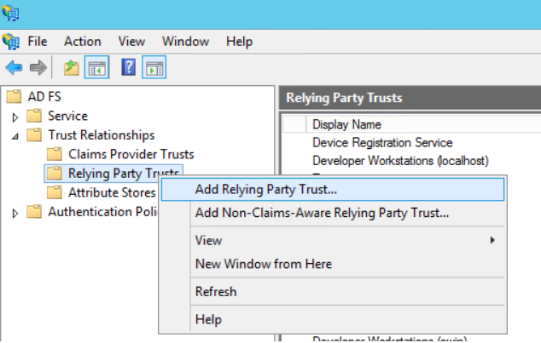

- On the first step of the wizard, click Start.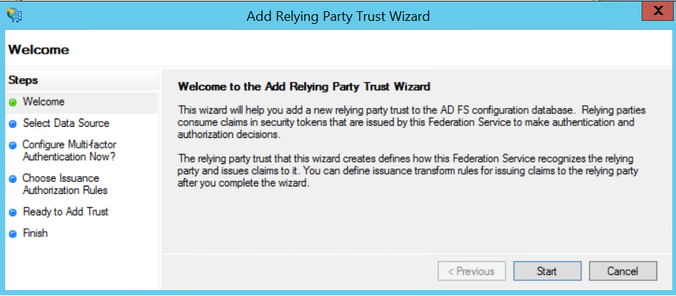

- On the second step of the wizard, select the option Enter data about the relying party manually. Click Next.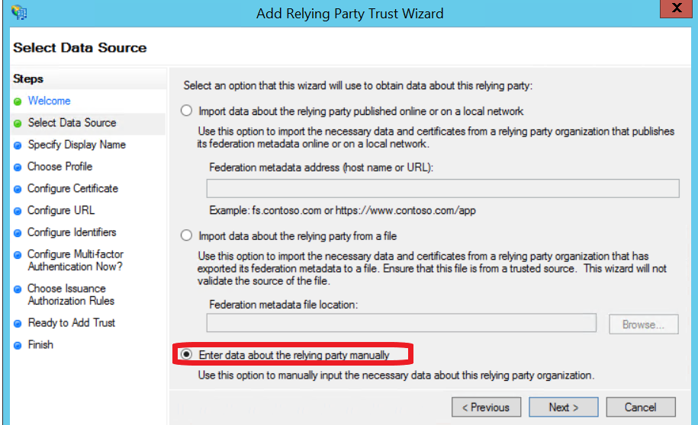

- On the next step, enter the name of the application as you would wish an I.T. administrator to see it displayed.
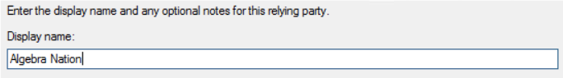
- During the next two steps, simply accept the default, or leave the input form blank.
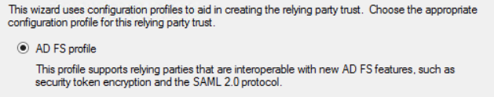
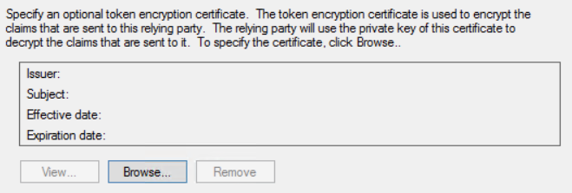
- On the Configure Identifiers step, add the base URL for Algebra Nation.
In fact, this value is arbitrary, but must match the value Algebra Nation's web application provides for the resource in the HTTP request/redirect that seeks an Authorization Code from the user/ADFS. See the section Example OAuth 2 Flow between Algebra Nation and ADFS (Data Hub) for details.
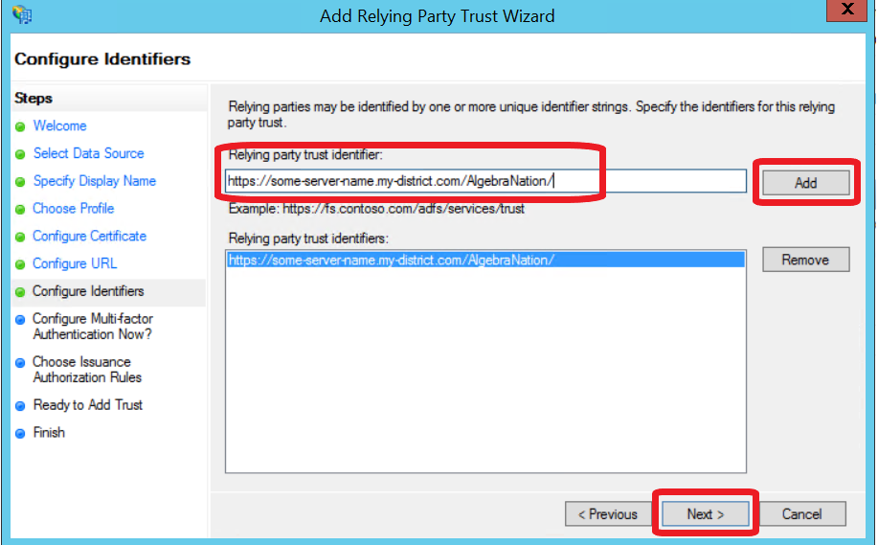

- Accept the default for the Multi-Factor Authentication step. This can be changed at a later time if desired.
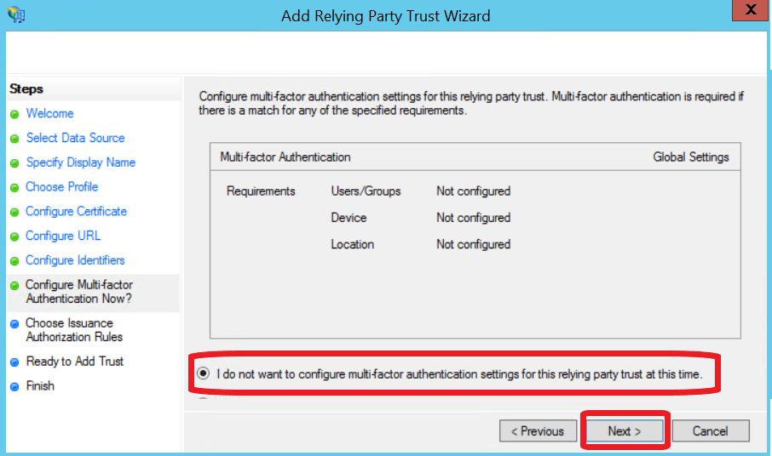

- Accept the default for the Choose Issuance step. This can be changed at a later time if desired.
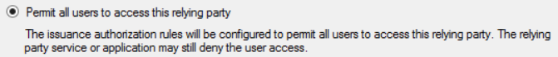
- On the step Ready to Add Trust, click Next.
- On the step Finish, leave the checkbox Edit Claims Rules checked.
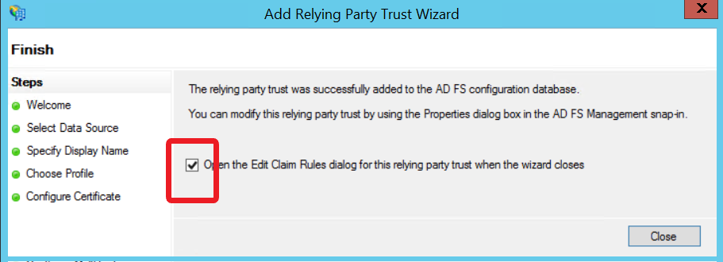
- Add the following two Claims Rules:
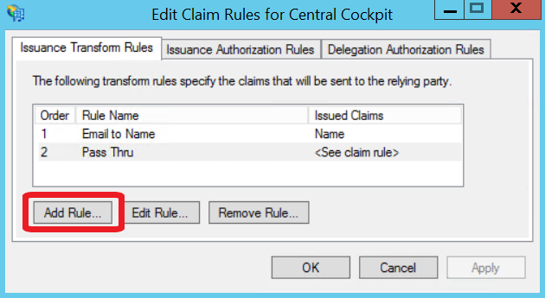
SEE SCREENSHOTS BELOW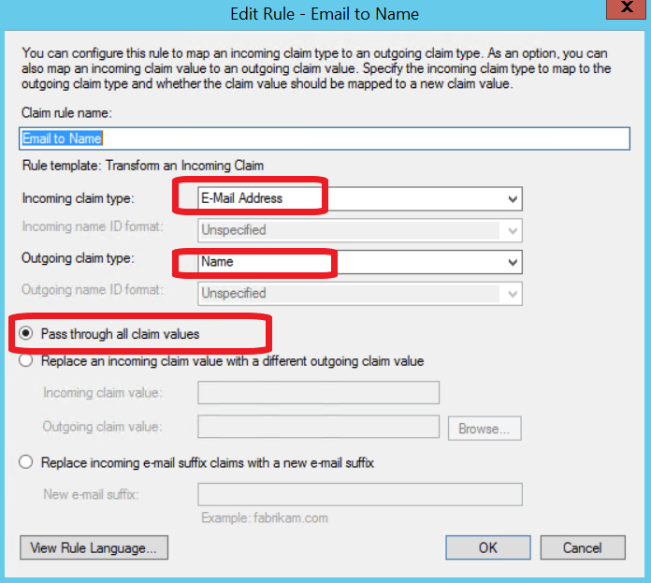
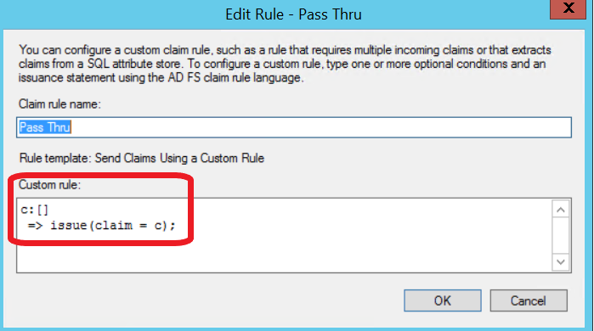

- NOTE: The ADFS Certifcate Thumbnail for ADFS may also be needed by Algrebra Nation. It can be found at: ADFS >> Certificates >> right-click Token-Signing Certificate >> Properties … >> tab Details >> Thumbprint.
