Mapping and Authorizations for MiLearn

As districts using the PowerSchool Student Information System begin to publish data to MiDataHub for the current school year, we were notified by PowerSchool that you will need to complete the MiLearn mapping and authorizations for the 2021-22 school year. The following instructions will assist districts with recreating those mappings in PowerSchool and authorization settings under the MiLearn section in the MiDataHub cockpit.

Mapping Access Roles in PowerSchool

PowerSchool is linking Access Roles to the role permissions in MiDataHub. Most districts will need to first change from using Group Security to Access Role security before mapping security roles.
- Click here for instructions on changing Group Security to Access Roles in PowerSchool
- After configuring Access Roles in PowerSchool, you will need to map those roles to the appropriate role within MiDataHub. Here is the listing of the Data Hub roles and their permissions within the hub.

  - The tab labeled “Basic Roles” provides the Roles name as they are listed in MiDataHub, and what access they have in MiDataHub
  - The tab labeled “Details on Roles” provides a detailed description of each of those permissions.
Be sure to give some thought to which MiDataHub permission you will grant to each of your Access roles in PowerSchool. These permissions will define who gets access to MiLearn.
- To map the roles just follow these steps in PowerSchool:
  - Go to System -> Code Set Mappings
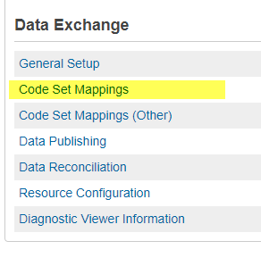
  - Choose Staff Classifications in your Code Set list
  - Map each of your PowerSchool groups (under Description) to the Data Hub roles (under Selected Downloaded State Code).
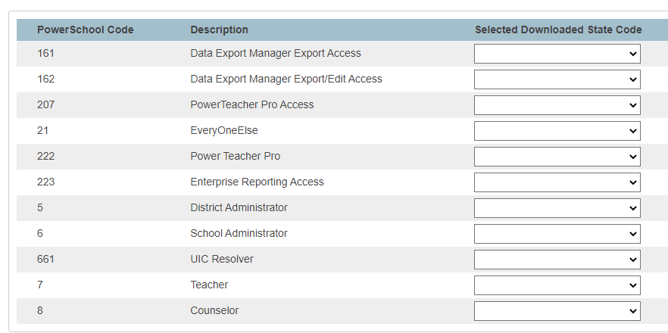
Recommendations:
- Any access role that has to be used with another role (Data Export Manager, UIC Resolver, etc.) should be left BLANK and not mapped.
- Currently all PowerSchool “staff” users are being mapped to the data hub role of “Support Services Staff” Because of this, it is recommended that you do NOT map any of your roles to the data hub role of “Support Services Staff”. This way you can exclude the data hub role of “Support Services Staff” from having any access to MiLearn, since ALL staff users in PowerSchool will have that access.
  - When completed, click the Save button
- Navigate back to the PowerSchool Data Exchange (location where data is published to MiDataHub) in the left navigation bar.
- Locate the Staff Associations resource and select the Run Now >Publish All option
  - Wait for this process to complete and proceed to next step.
- After completing the steps above, please log into the MiDataHub Cockpit https://launchpad.midatahub.org
- Run the Role Validation Report for your District by navigating to your MiDataHub cockpit and selecting Reports -> View District Reports -> Data Quality -> Role Validation Report
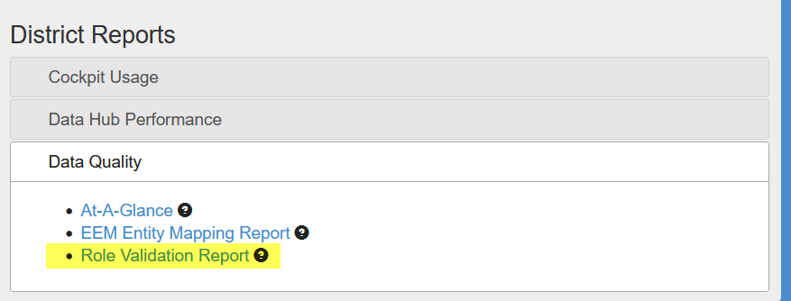

- Check to make sure that users in your schools have the role that you expected them to for the data hub.

  - Remember, every “staff” member will show the “Support Services Staff” role if you have not published and mapped your access roles correctly. If users appear in the correct roles please proceed to the next step
- By completing the steps above you are ready to set up your MiLearn Authorizations.

Setting Authorizations in MiLearn via the MiDataHub cockpit

- From the tab options beneath the breadcrumbs, expand the MiLearn menu and select Authorizations.

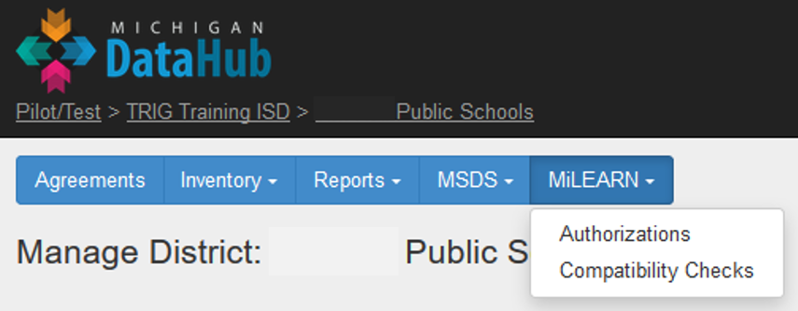

The Authorizations page will display a table of reports (in the first two columns) connected to student/parent/staff roles (in the first row).
Default roles that are constant are Student and Parent.
For staff, the Ed-Fi Staff Classifications displayed are dynamically driven by the data the district populates in the Data Hub. As such, they may be different for each District.

EdFi Staff Classifications
Assistant Principal | LEA System Administrator | School Specialist
Assistant Superintendent | Librarians/Media Specialists | State Administrator
Counselor | Operational Support | Substitute Teacher
Instructional Aide | Other | Superintendent
Instructional Coordinator | Principal | Support Services Staff
LEA Administrator | School Administrator | Teacher
LEA Specialist | School Leader
- By default, there are six (6) access levels, which have the following viewing rights in the MiLearn Portal:
- Only myself: Has rights to see reports displaying information about the user. (This is the default setting for Students.)
- Only my child(ren): Has rights to see reports displaying information about the user’s child or children. (This is the default setting for Parents.)
- Only my classes: Has rights to see reports displaying information about the user’s assigned classes or sections, including each student assigned to those classes or sections. (This is a typical setting for Teachers.)
- All classes in my school: Has rights to see reports displaying information about all classes and students assigned to the user’s school. (This is a typical setting for Principals and Counselors.)
- All schools in my district: Has rights to see reports displaying information about all classes and students within the user’s district. (This is a typical setting for Superintendents.)
- No access: User has no access to view any data or reports. (This could be used for staff with no educational need to know student data)

- On the Authorizations page, select the appropriate student access level that corresponds to each Ed-Fi Staff Classification in the header row of the table. Do this by clicking on the dropdown arrow and selecting the appropriate access level.

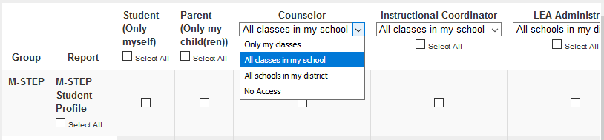
*Note that your changes will not be saved until you click the Submit button at the bottom of the page.
- Next, select the reports to make viewable by each student/parent/staff role. Use the checkboxes to select or un-select the appropriate viewing rights for each role for each MiLearn Report.
- Note that several options are unavailable for certain reports, as designated by N/A in place of a checkbox. For instance, a user within the “Only myself” Access Group does not have the ability to view the M-STEP Student Roster report.

Here is an example:
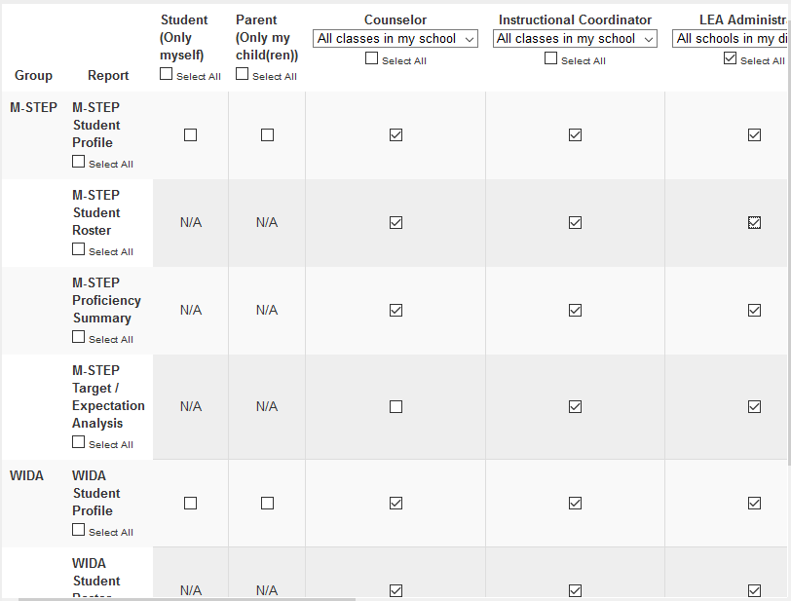

- When done setting the appropriate viewing rights, click the ‘Submit’ button to save all changes made. A confirmation box will pop up upon successful saving:
- After settings have been saved, you can return to this screen at any time by expanding the MiLearn menu and selecting the Authorizations link. Any changes made to access level mapping or report authorization will be saved once you click the Submit button.

Notes
- Student and Parent authorizations should have remained the same from last year.
- If you would like to know what your MiLearn authorizations settings were for last year, please contact hallt@michigan.gov

