Mode of Instruction process:
From district home page in the cockpit:
- Reports/District Reports/Outbound Integration Reports/Mode Of Instruction Export
- Save as csv.
Will save as Cockpit_18.csv (may add a (#) to the file if a duplicate)
- Open the file in csv editor of your choice.
Fill it in:
CohortIdentifier needs to be one of ‘FULLY REMOTE’,’FULLY IN-PERSON’,’HYBRID’
BeginDate is required
EndDate is optional.
*If you want to show movement of the student, insert a new row with the appropriate dates
- Save file (.csv)
- Zip the file (deflate 32)
Return to Cockpit District page
Add inbound integration
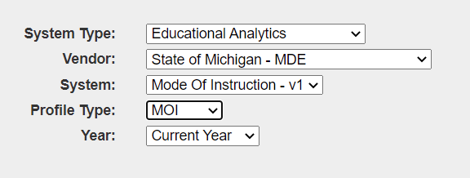

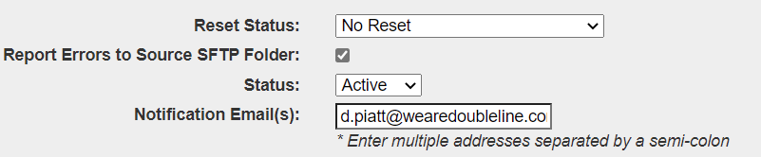
The 'Report Errors to Source SFTP Folder' will write the inbound errors to a file in the SFTP folder.
- Submit and run…
If Cohort Identifications are not correct, it will fail validation. Also, if BeginDate is missing, it will fail also.
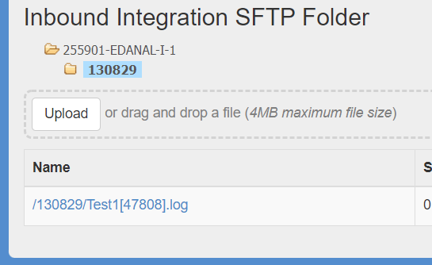
The api log file is posted to the SFTP Inbound Integration folder. It contains any errors that would be reported to the Inbound Bulk Exceptions report. The error data can be viewed via the file or in the inbound bulk exceptions report.

