PowerSchool Data Exchange Configuration Initial Ed-Fi Setup

Enable DEX Plugin
PowerSchool Data Exchange (DEX) is delivered to PowerSchool as a plugin. The plugin will need to be enabled to access to the data exchange components between PowerSchool and Ed-Fi. The DEX Plugin is installed automatically as part of state reporting releases and can be enabled by navigating to the Plugin Management Dashboard. Please do not delete this plugin as it is not able to be reinstalled.

Section 1: Getting Started
Sign into PowerSchool at the DISTRICT level

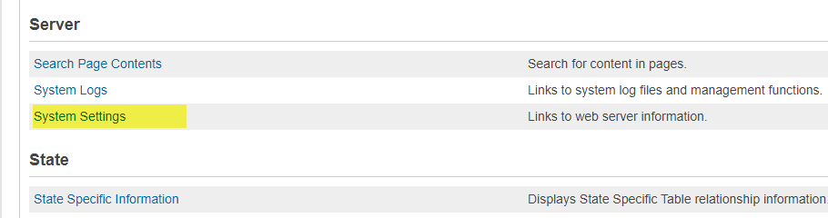
- From the start page, select SETUP>SYSTEM>Server>System Settings:

- Select > Plugin Management Configuration.
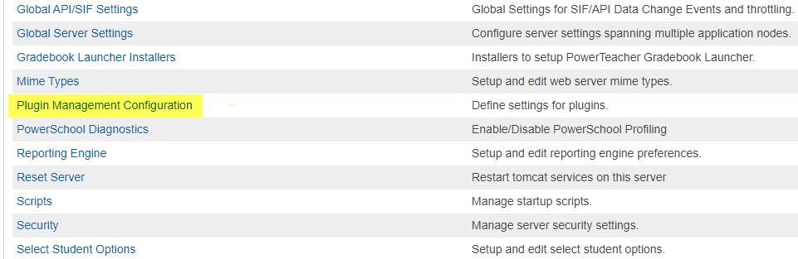

- In the Plugin Management Dashboard, select the Enable/Disable checkbox next to PowerSchool Data Exchange (DEX). Wait a few minutes for the plugin to be enabled:

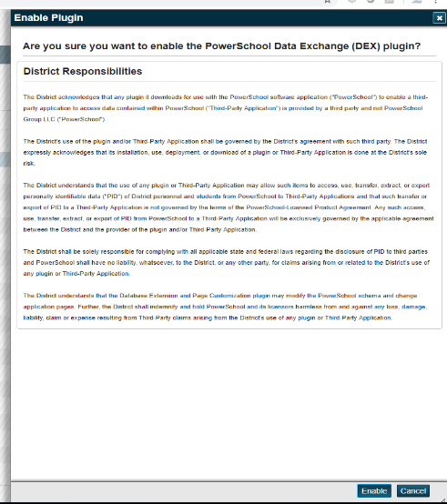
- When the Enable Plugin box pops up, click Enable.
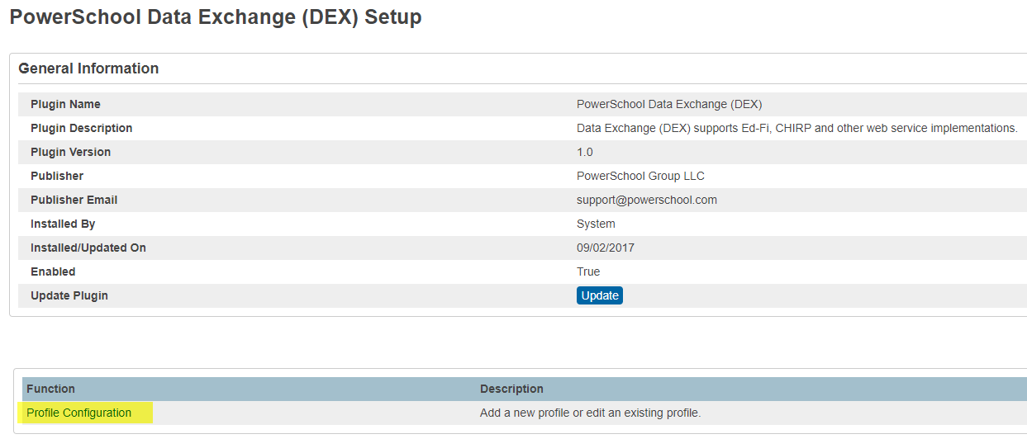

- After the plugin has been enabled, select PowerSchool Data Exchange (DEX) and click on the profile configuration:
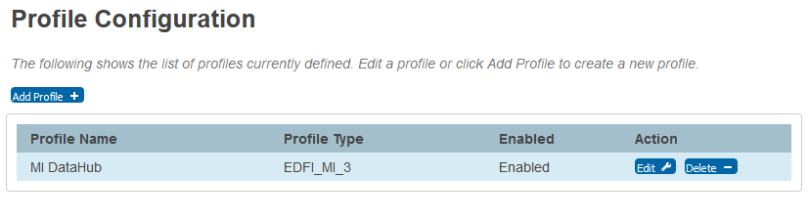
- The profile will be named MiDataHub and should default to Enabled.

- Your new profile should show as a link on the left side of the screen under a new option called Data Exchange. If the profile does not show up, please email support@midatahub.org, as there might be customizations blocking the link from appearing. Please follow this link to a document outlining the process to correct the profile not showing up in the left navigation bar due to installed customizations. (Profile not showing up in the left nav bar)

Section 2: Configuring the PowerSchool Data Exchange
The setup page provides a user interface for entering various configurable settings. Settings such as enabling/disabling the entire data exchange, authentication, and operational frequencies are user-based settings.

- To begin configuration, navigate to the Start Page link in the breadcrumbs.

- Select SYSTEM>Scroll to the bottom of page and find Data Exchange>General Setup
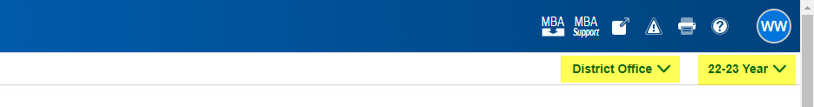
If you do not see Data Exchange, make sure the School is set to “District Office”

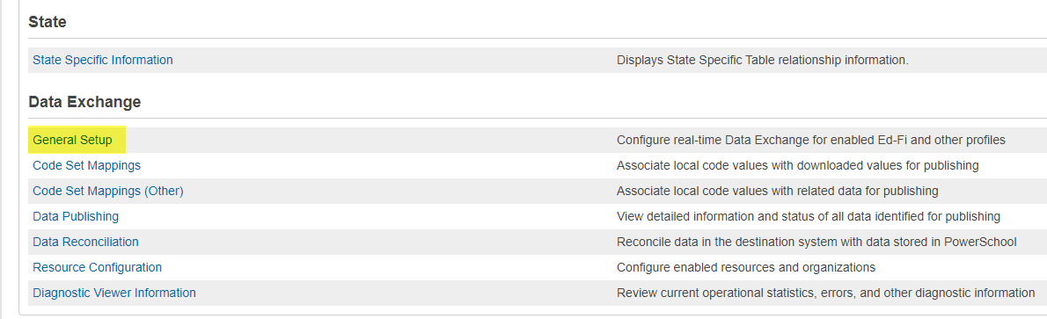
- Click General Setup

- You should now be on the Data Exchange Setup screen (See right):

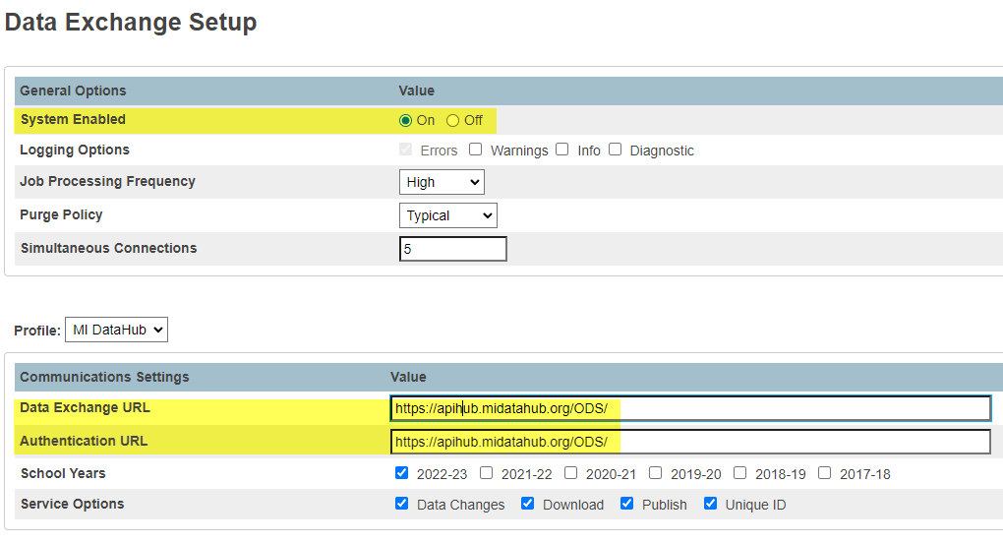
- From the top down:
- System Enabled - ON
- Profile Pull down - Select the profile created above

- Verify the profile is for MiDataHub.
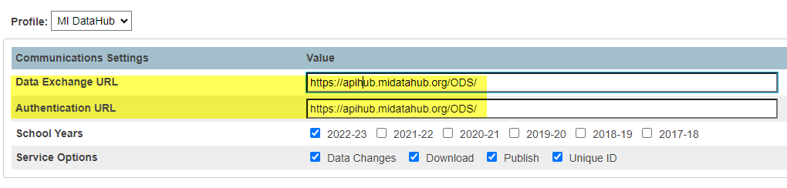

- Enter the Authentication URL which can be found in the Data Hub Cockpit (see step 10 below if you need to locate this in the Data Hub Cockpit) under the PowerSchool API Integration. PLEASE NOTE this is the Authorization URL in the data hub. Copy and paste this into the Authentication URL in PowerSchool.

- Verify the current school year only is selected for this profile.

- Obtain the Data Exchange URL and Authentication URL(labeled different in the Hub vs PowerSchool, Secret, and Key by logging into the Michigan Data Hub by visiting www.midatahub.org and clicking on the “Log In” Button.

- Upon logging into the Data Hub, select the district you are working with, and locate the API Integrations in the bottom right corner. If you are creating a new integration proceed to step 12, if you already have an API integration created in the Data Hub proceed to step 13.

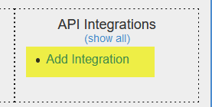
- To create a new API Integration for PowerSchool, select Add Integration (Bottom of the API Integration box).
- Select the following criteria:
- System Type: Student Information System
- Vendor: PowerSchool
- System: PowerSchool - v1
- Upon adding these parameters please click the submit button to save your selection and newly created API Integration.
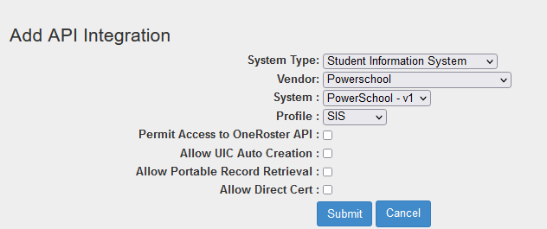
- Locate the Student Information System - PowerSchool API Integration in the API Integration box and click on it. Upon opening the API integration for PowerSchool, you will need to copy the following information back to the communication settings in PowerSchool (Please note the two fields you are copying from the data hub cockpit is not in the same order in PowerSchool)
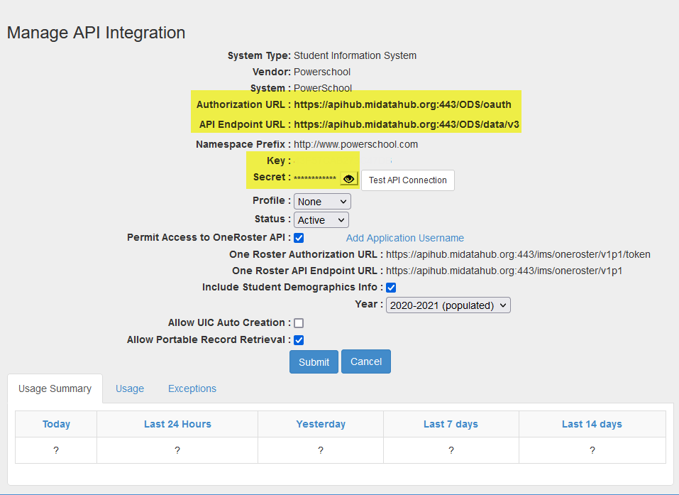
- Authorization URL (Data Hub) to the Authentication URL (PowerSchool)
- API Endpoint URL (Data Hub) to the Data Exchange URL (PowerSchool)
- Key (Data Hub) to the Authentication Key (PowerSchool)
- Secret (Data Hub) to the Authentication Secret (PowerSchool)

- Back in PowerSchool click on the “configure” button under actions and to the right of your district name.
- Switch LEA Enabled to ON
- Copy the KEY from the Data Hub Cockpit back to the PowerSchool screen

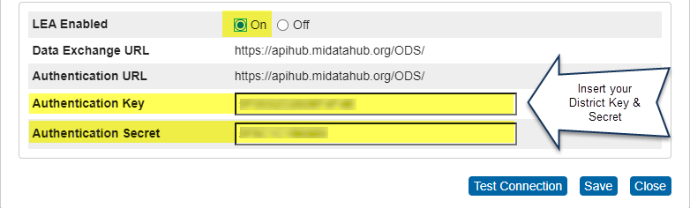
- Copy the Secret (by clicking on the eyeball) over the PowerSchool screen
- Once the LEA Enabled is flipped to on, and the Key and Secret has been entered please click Test Connection, and then wait for the test connection option to successfully process. Once the connection setting has passed click save and close.

If you are unable to establish a successful connection, please contact the data hub help desk by submitting a ticket at support@midatahub.org.

- After a successful test please proceed back to the PowerSchool integration page by clicking on the profile name in the left navigation panel. This is the profile you named above. You should be at a screen similar to below. If the named profile does not appear on the left navigation bar within 5 minutes you might have customizations enabled that are blocking the Data Exchange from publishing the profile. Please see the configuration guide (Profile not showing up in left nav bar). This guide will provide further information on how to configure customized pages.
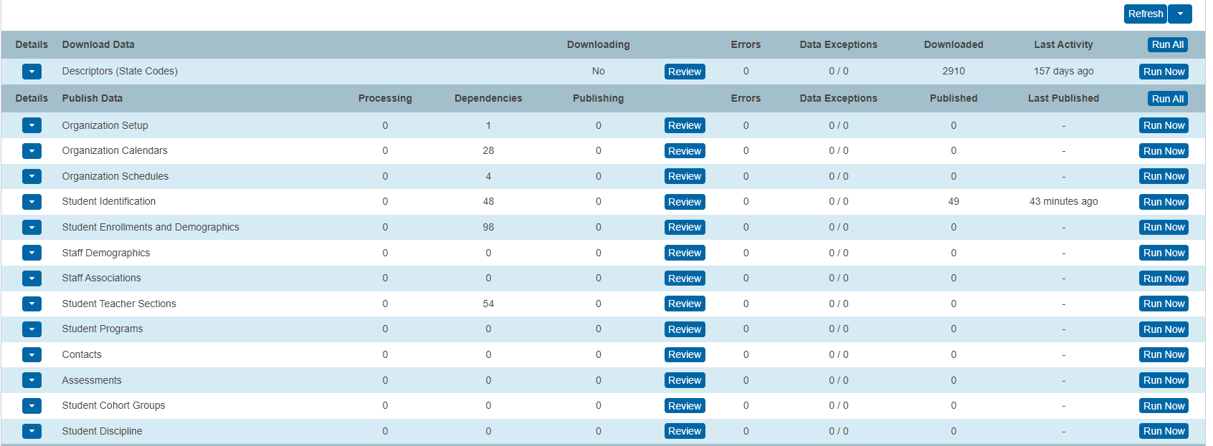

- Please proceed forward publishing only one category at a time. The Ed-Fi Dashboard is listed in a hierarchy of categories. Most of the time, each category is dependent on the category before it. When publishing data from the Ed-Fi Dashboard, PowerSchool recommends that you start at the top and work your way down. Start with the first category, Organization Setup, and then move to the next category, Organization Calendars. Once Organization Calendars is complete, then move on to Organization Schedules and so on. Failing to do so might result in the Data Exchange freezing up and ultimately having to be reset.
***You might also want to update the interval rate to 30 seconds under the refresh pull down menu to monitor the progression.

- Start by downloading the Descriptors (State Codes), this is the first option available on the screen. Do this by selecting Run Now. Wait patiently for this to complete. It could take up to 30 minutes. You will know this has completed when it says “NO” under downloading.
  - When completed, the downloading section will have a “No”
  - The downloaded descriptor codes.

- After the Descriptors have been downloaded you can proceed forward with the publishing of the remaining categories, again one at a time.

- There are a few things to consider when configuring each category for publishing. First and foremost, make sure you ONLY configure to publish one category at a time. This simply means Publish one category at a time, upon completion (no data appearing in either the processing or publishing columns) and rerunning a publish missing. After the publish missing has completed you can proceed forward to the next category.
Also, dependencies and errors will be referenced moving forward. Please remember a dependency is a data element that is missing that must be updated or reviewed because that record will not publish to the hub without it. An example of a dependency might be a missing UIC number. Without the UIC number, the student will not load in the hub. An error is a field within a record that is missing or incorrect. An example of an error might be a phone number that is over the limit on characters.

- Start by clicking the Run Now button on ORGANIZATION SETUP and select the PUBLISH ALL option. You will notice after a few seconds/minutes that data will begin publishing from PowerSchool (in the processing column), slowly moving to the publishing column, then to the published column. If there is a number greater than 1 in the published column that means you have successfully published data to your ODS in the Data Hub.

PLEASE note upon running a publish all more than likely not all your data will be published to the hub. If you have a ‘0’ in the processing, Publishing columns that means the system has done the initial publishing of data. IF you have any dependencies or errors after running a publish all, please run a publish missing from the Run Now option. This will reprocess all the dependencies and errors. When the Processing and Publishing columns show a ‘0’ again please review, if there are dependencies still rerun a publish missing and wait patiently. If after a third time of running the publish missing and you still have dependencies or errors, there might be a discrepancy in the data that needs to be reviewed. This would be best accomplished by either reaching out directly to PowerSchool or the data hub.

- Upon successful publishing of data on Organization setup, proceed to publishing the next category with the same steps above. Publish All and then a Publish Missing to clean up records.
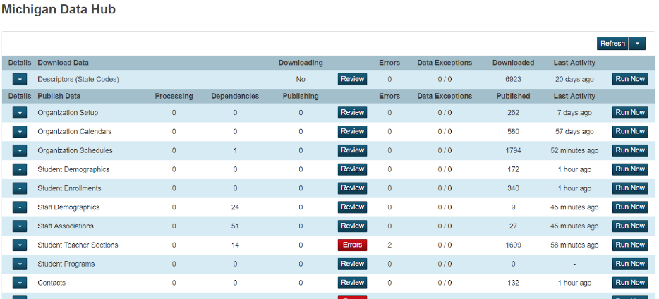

- After starting the publishing of the Organization Setup, you can proceed forward with starting to map your code set mapping configuration.

The code set mapping configuration is located under the Setup> System > Data Exchange > Code Set Mappings.

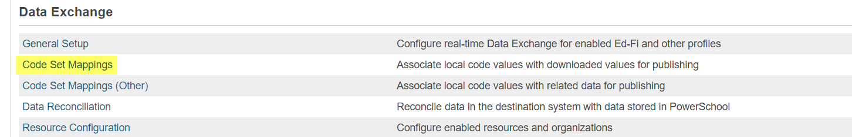

- Under the code set mappings option, you will need to ensure the correct profile is selected for which you will need to configure. As of now, you will only need to map the following:
- Entry Types
- Exit Withdraw Types
- Grading Periods
- Residency Status Indicators
- Attendance Event Categories
- Calendar Events
- Staff Classifications (only if you currently use MiLearn)
- Behavior Categories if using EVAAS or Eidex

- During the code set mapping configuration, you will need to match the PowerSchool description to the appropriate downloaded state code description found in the “Selected Downloaded State Code” pull-down menu. Please select the code that best matches WITH the numeric preference. If you are planning to use the dashboards, EWS tools, MiLearn and other technologies that require roles please follow the instructions for the mapping of access roles by clicking the following guide: Mapping Access Roles in PowerSchool.
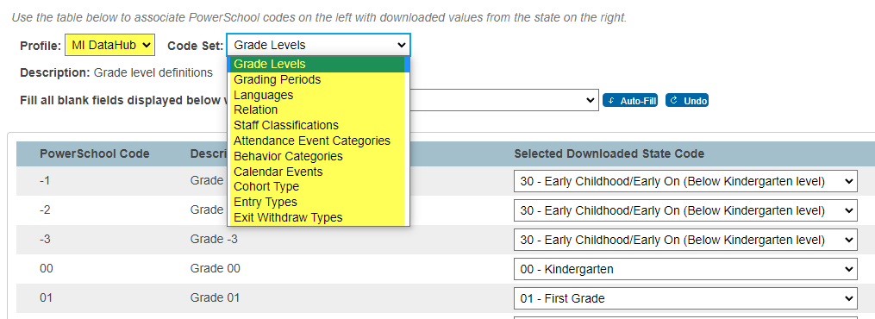

For further assistance with the code set mappings please contact the support helpdesk at support@midatahub.org.

Below are notes by each category of data published.
Ed-Fi Categories and Resources – PowerSchool SIS Michigan

Descriptors (State Codes)
After these are downloaded, be sure to go into System>Ed-Fi Reporting>Ed-Fi Code Set Mapping to map your codes.

Organization Setup
Usually requires at least two additional “publish missing” to get it to run successfully. Biggest issue is that new courses don’t typically publish automatically, requiring a periodic “Publish Missing”. This has been submitted to PowerSchool for Correction.

If you do run into Dependency errors with Schools not publishing:
- Go under District > Schools/Schools Info
- Choose the school not publishing
- Under “Other Information” make sure there is a School of Facility Code
- Make sure the School type is filled in
- If you have to fill in this information, go back into System Reports and try to “Publish Missing”

Organization Calendars
This category represents information about sessions, grading periods, and calendars as published within the Organization Calendars category. Biggest issue seen is where calendar dates are referenced, but not defined.

Organization Schedules
This category captures the organization course, section, and bell schedule information for the school year. Biggest category of dependencies are classes that don’t have a meeting time (period). Typically, these are classes that have no students schedule and shouldn’t flow anyways.

Student Demographics
This category captures the core student demographic record and contains identifying information as published in the Student resource. The biggest reason for errors are for students who have an address with the state in mixed case, such as Mi rather than MI. Use the Make Current Student Selection button to select these students and go to the Address tab to correct. The biggest reason for dependencies are students who are missing UICs. There is also an issue where some students show as dependencies for School Enrollments, where the student has exited the district. This one needs to be addressed by PowerSchool.

Student Enrollments
These break into two pieces, as Student School Association and a Student District of Residence (DOR). The student school associations typically require a student demographic to be published, so the missing UIC cascades down as an issue. The DOR records typically show as an issue if the district isn’t listed properly on the Districts of Residence area in the District Setup. After adding a new District of Residence, do a Publish Missing on Organization Setup before doing a Publish Missing on Student Enrollments.

Contacts
Make sure to click the Run Now button and do a Find Contacts before publishing. Only parents who have the mother and father fields in the Last, First format will publish properly.

Staff Demographics
The biggest reason for staff dependencies is a missing PIC code. Many times, the staff dependencies are support staff that typically don’t have a code. Staff who are tied to sections are the most critical. There is a known issue where staff don’t publish even though they have a PIC. We are working with PowerSchool to identify the reason this is occurring.

Staff Associations
Dependencies are largely due to staff not publishing due to a missing PIC code.

Student Teacher Sections
Typically, teacher associations as dependencies more than student associations. This is due to dependencies on staff demographics and staff associations that need to be resolved.

Student Programs
This view captures details about each program in which a student participates or receives services from as published in the StudentProgramAssociation resource within the Student Program category. The layout includes the School Name, PS Student Number, Student Name, Grade Level, Program Name, Entry Date, Exit Date, State Student Number, Last Publish Date, and Publishing ID.

Student Discipline
Dependencies are typically due to student demographic and school association dependencies.
On Demand Data
- To publish the “On Demand Data” you will need to schedule this
- activity. This data should be scheduled in two phases.
a. The first phase will push all available data
b. The second phase will push data changes on a regular basis.
- Click “Schedule” for the On Demand Data category (Attendance in this case)
- Click OK on the pop-up icon
- For the Data Publishing Option, select “PUBLISH ALL”
- Click Schedule and ensure that Run Once is selected
- Choose a Start Time when your PowerSchool will not be in use. Suggested after 10 p.m. until early a.m.
- Click Submit

Student Attendance
Relatively few errors. Dependencies are typically due to student demographic and school association dependencies. We also see a lot of dependencies for Section Attendance Taken, where the staff person is not defined. To fix that, the appropriate staff record needs to be sent.

Student Grades
As long as sections publish for students, these are typically error free.

Student Transcripts
There can be a large number of dependencies on Course for student transcripts. The reason for this is that courses offered in previous years, but not the current year, are not published. As such, the transcript records cannot publish. PowerSchool is aware of this and we are awaiting a correction.

Additional Configuration Guides:

Special Operations Tools
Mapping Access Roles in PowerSchool
Changing from Security Groups to User Access Roles
Profile not showing up in left nav bar
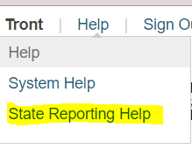
UIC Services
Steps to remove Organizational data in Ed-Fi

Additional Plugin

Documentation:
Online Michigan State Reporting Guides

To access directly from PowerSchool, in the upper right hand corner click Help and then State Reporting Help.

Error Resolution details below are provided by PowerSchool and pulled from the link below:

https://docs.powerschool.com/USATN/ed-fi-reference

https://docs.powerschool.com/USAMI/ed-fi-reference

https://docs.powerschool.com/ALLSTATES/getting-started-with-ed-fi/troubleshooting

