District Alert Subscriptions page

(with no subscriptions)
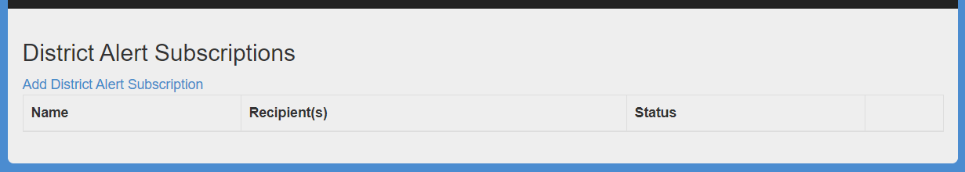

(with one active subscription)
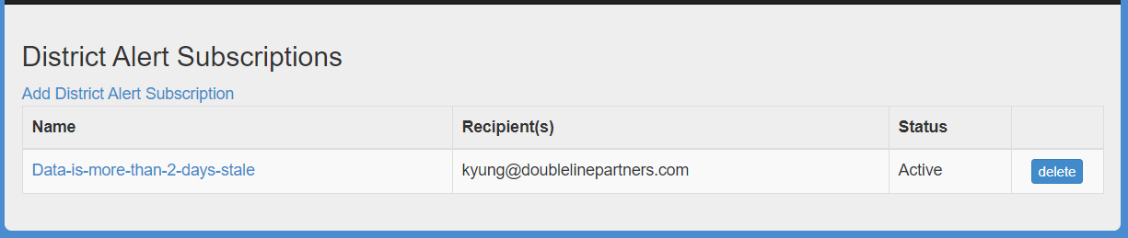

(with multiple subscriptions – active and inactive)
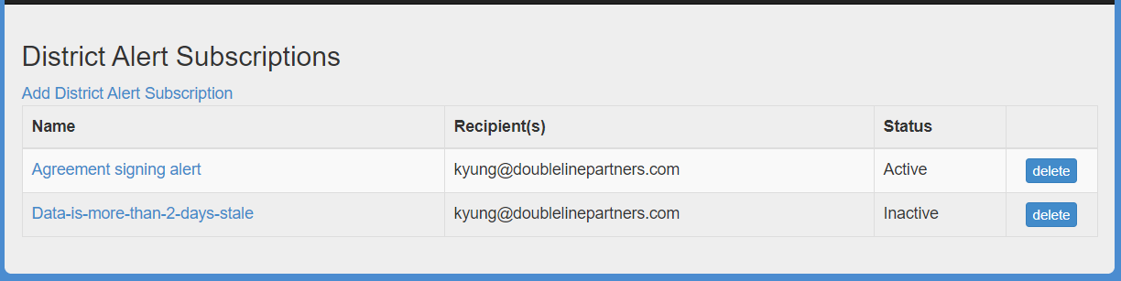

Add District Alert Subscription page

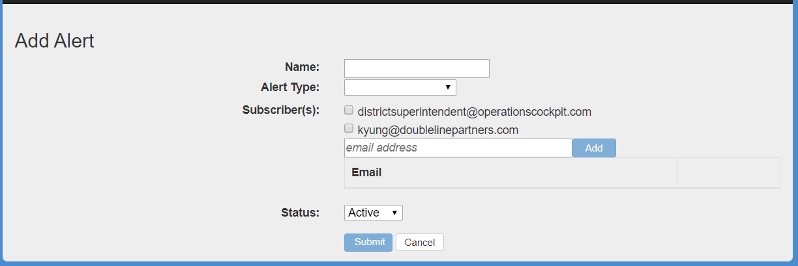

(for scheduled activity Alert Type)
- Alert Type of Scheduled Activity offers dropdown of alerts pre-populated into the inventory. Conditions are defined via user-entered parameters.
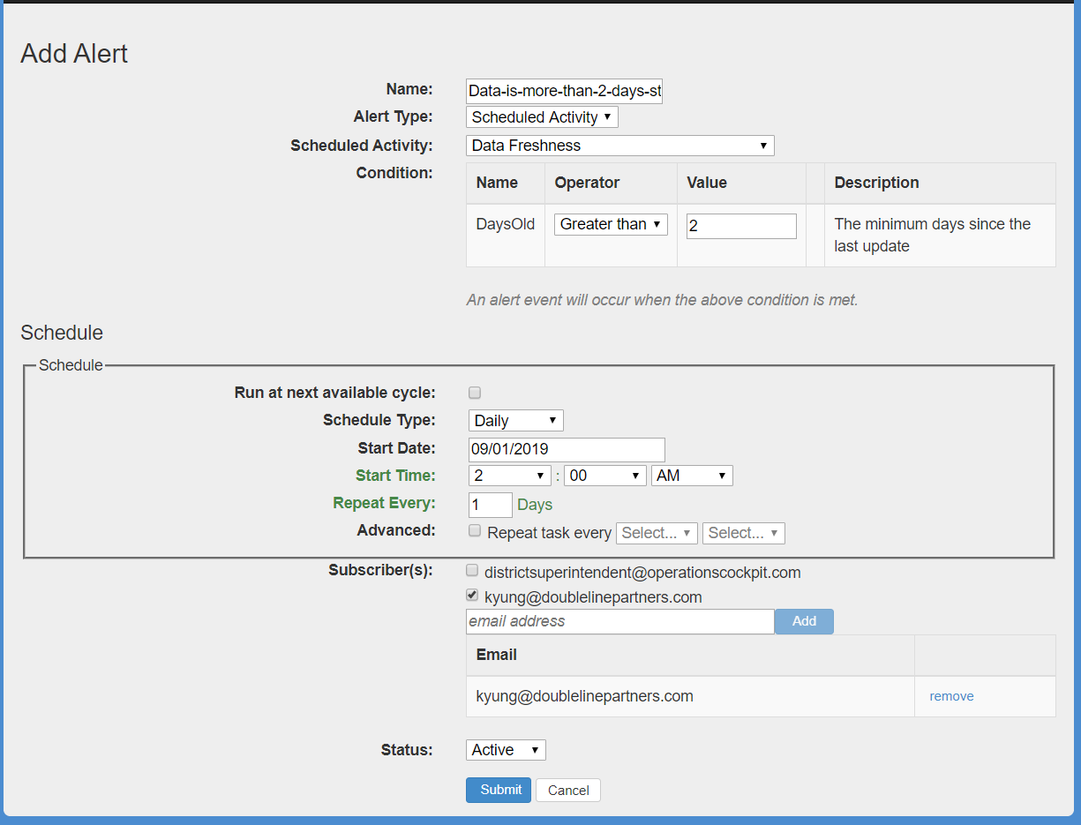

(for audited activity Alert Type)
- Alert Type of Audited Activity offers dropdown of alerts that are tied to events that are relevant to the Audit Log
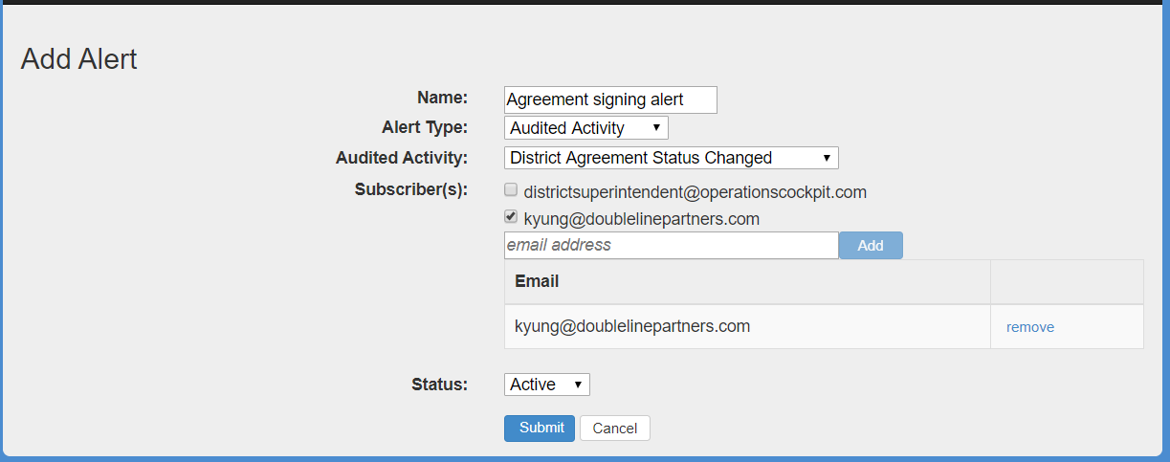

Edit District Alert Subscription page

(for scheduled activity Alert Type)
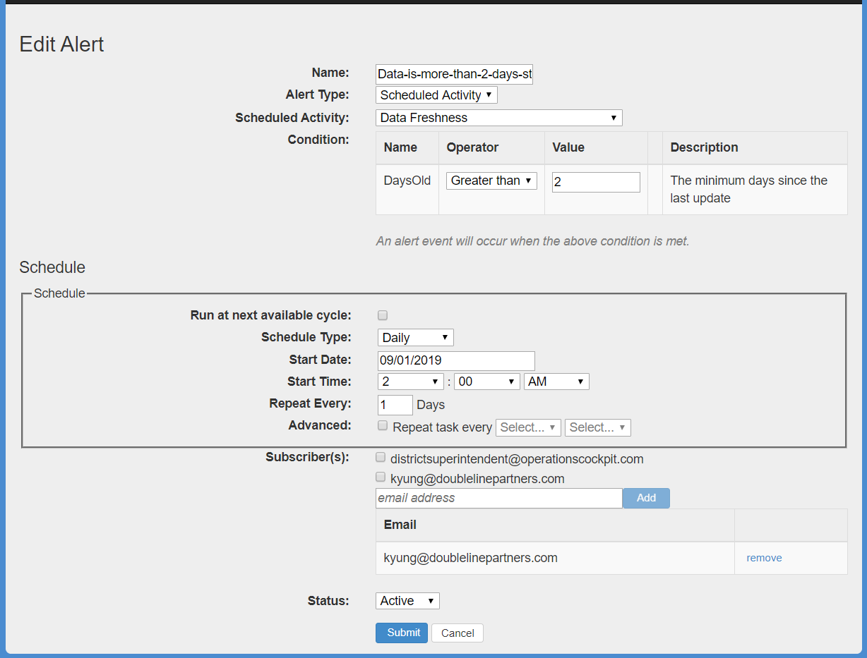

(for audited activity Alert Type)
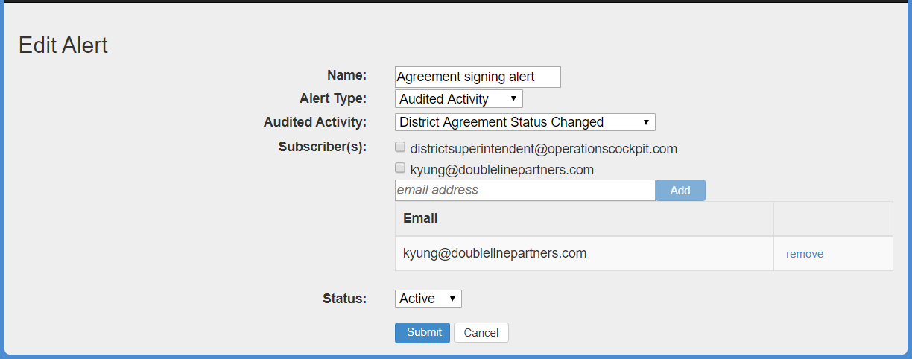

Alert Email

To: [subscriber(s)]
From: [data hub region]
Subject: MiDataHub Alert for [district name] – [alert name]
Message:

(audited activity sample)

MiDataHub Alert
District | Test District (99999)
Alert Name | Agreement signing alert
Details | MiLearn Opt-in Agreement was rejected
Date/Time | 11/11/2019 2:53:06 PM

Sent to: [subscriber(s)]

(scheduled activity sample)

MiDataHub Alert
District | Test District (99999)
Alert Name | Data-is-more-than-2-days-stale
Details | daysOld(3) > 2
Date/Time | 11/11/2019 2:53:06 PM

Sent to: [subscriber(s)]

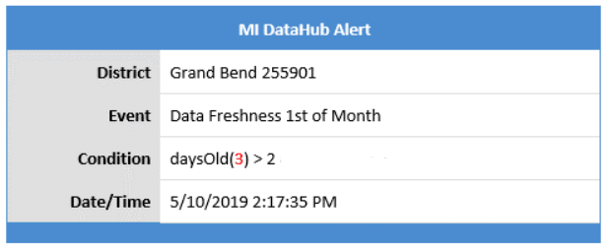

Technical Details

Audited Activities:
- Eligible activities are those that are deemed an ‘audited activity’.
- Table name to look up list of audited activities is log.AuditLogType. This is only to review the list. Additions to audited activities are carried out via the code.

Scheduled Events:
- Table name is [operation].[TaskProcedure]. Content is either a Runbook or a Stored Procedure
- Stored Procedure has certain requirements around parameters in order to be able to be alerted on. Example of procedure is [cockpit].[DataFreshnessCheck].

Alert Email:
- Alert emails are sent from midatahubcockpit@[region].org.

