Steps to configure the OneRoster API in the MiDataHub cockpit

**Step 1:** In the MiDataHub cockpit, create an API integration for the system you are seeking to build the OneRoster API for. Start by clicking “**Add Integration**” under the API Integrations

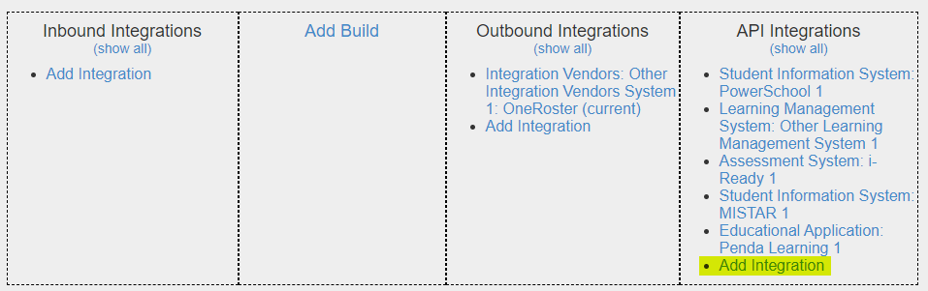

**Step 2:** Create the API integration for the system by verifying the system is available under each topic. For this example we are using “Penda Learning”. Make sure to select the checkbox next to “**Permit Access to OneRoster API**”. Also, double check that “**Include Student Demographics** “ info is selected. Last, make sure the appropriate Year is selected under the “**Year**” pull down menu. This is the year of data that will be pulled for the OneRoster API. After all your selections are made, click “**Submit**”

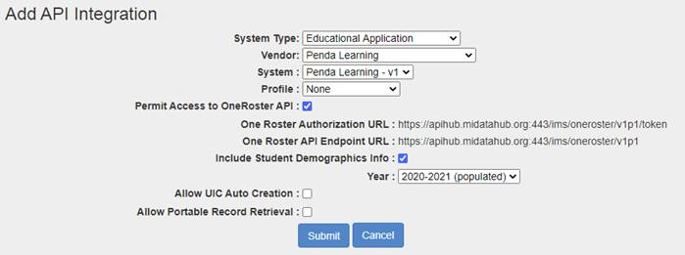

**Step 3:** Open the API you just created by navigating down to the API section and selecting the “Penda Learning” (or whatever system was created) in the Data Hub cockpit screen. Verify the selections made in step 2 above are correct. Make note of the Key, Secret, and URL’s (highlighted in screenshot below). This is information you will need to provide the account representative for the system you are configuring. **It is highly recommended that you share the Key/Secret with the company in a secure, possibly encrypted manner.**

