Instructions to Update a Certificate for a Custom Google SAML Application

- Login into the google domain as an admin
- Select the Admin icon from the waffle
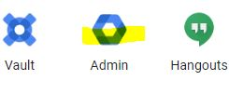
- Use the top search bar, type web and mobile apps and select the web and mobile apps waffle.
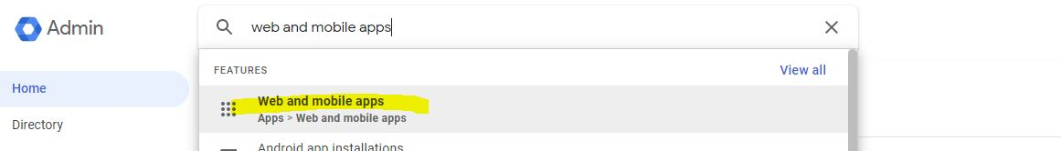
- Select the midatahub custom saml application*:
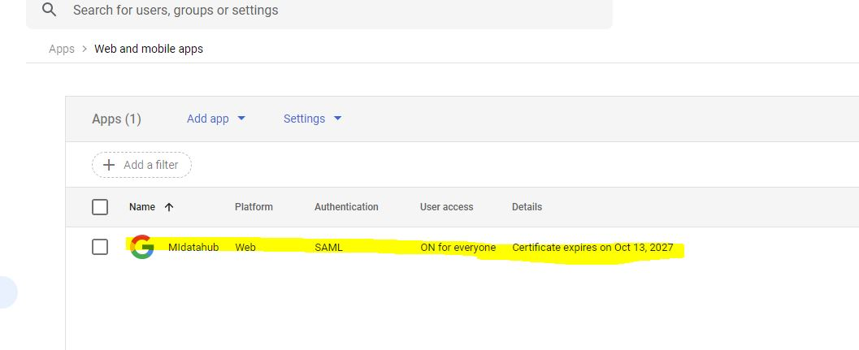
*the name maybe different depending on how it was originally configured for your district.
- Once the application is open select service provider details:
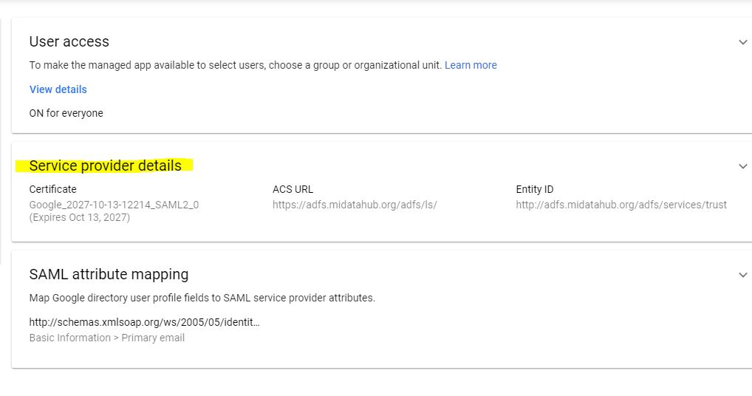
- Select manage certificates:
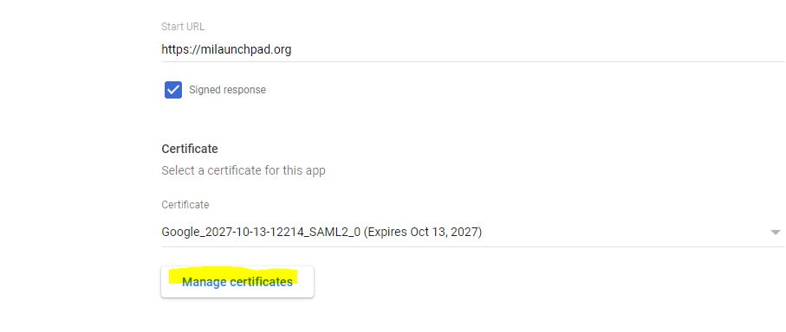
- Select add certificate
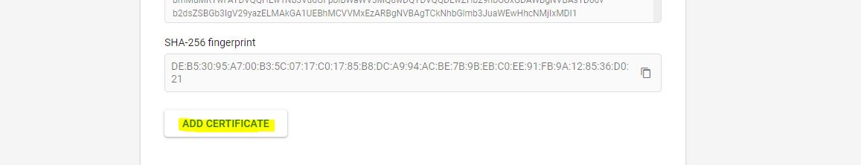
- Once the new cert is added close the SAML Certificates window:
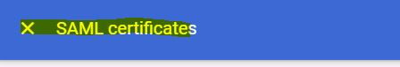
- Under service Provider details select the Certificate dropdown:

- Select the newly generated certificate (if the newly generated cert is not available refresh the page):
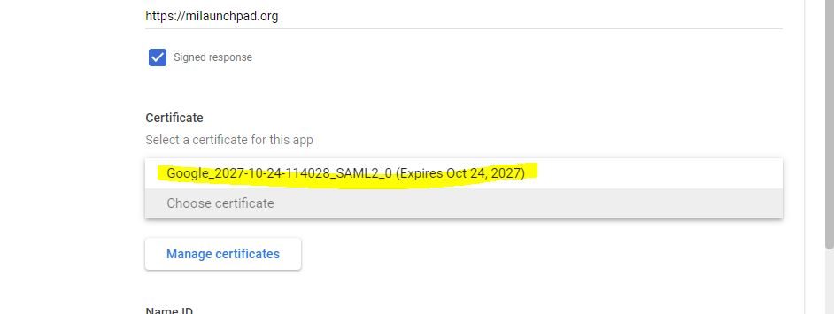
- Select Save at the bottom of the page
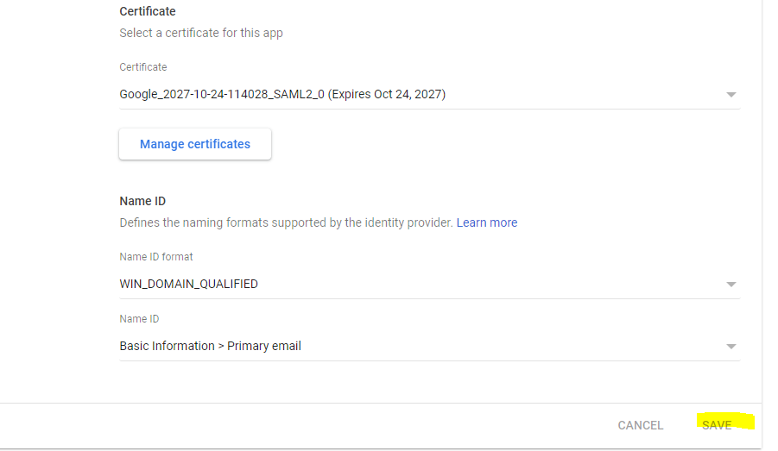
- Select download metadata from the left navigation:
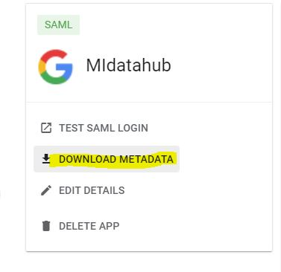

- The following dialog is presented – select the download metadata button
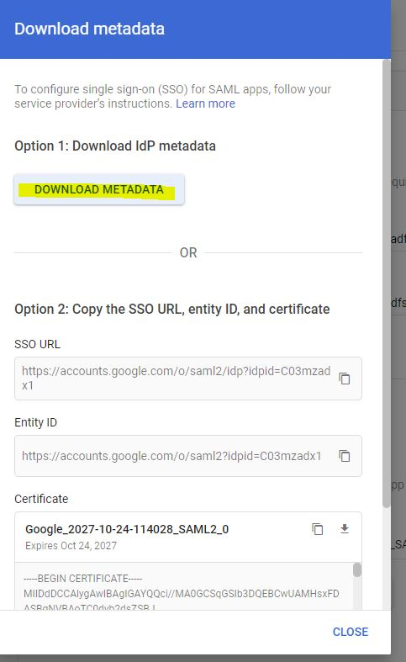

- Confirm the metadata has the new cert data by navigating to the downloaded metadata file and open it in a text or html browser window you should see the valid until tag reflects the new cert’s expiration date:
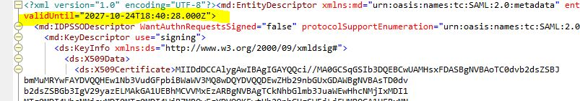

- Once confirmed that the new cert is contained in the file, please open a ticket to support@midatahub.org requesting the federation be updated and attach the file.

