MiDataHub – Configuring i-Ready for Assessment Results
The i-Ready integration consists of an API Integration, which allows for the sending of assessment (diagnostic) results back to MiDataHub via the Ed-Fi API. Below are the configuration steps for those pieces.

- Reach out to your Curriculum Associates Partner Success Manager and notify them you are interested in having diagnostic results from i-Ready sent to the MiDataHub.
- Confirm Roster and Class Enrollment Data are in the MiDataHub. MiDataHub Support (https://www.midatahub.org/support/) can assist if you have questions about how to do this.
  - One of the student Ids in i-Ready MUST match the studentUniqueId in the MiDataHub. If they do not match, talk to your Partner Success Manager about how you can get the correct student Ids into i-Ready (options vary depending on how you currently roster your students into i-Ready).
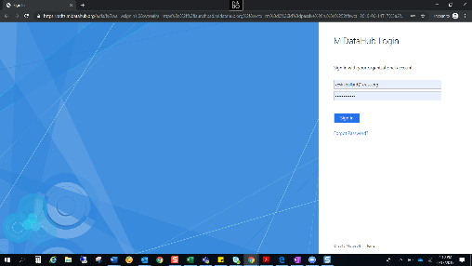
- Configuring the MiDataHub:
  - log into the cockpit by selecting the “LOG IN” button found at the top of the screen at www.midatahub.org or by clicking here.
  - Navigate to your district page.
  - Scroll down to the bottom of the screen and look at the API Integrations to see if a suitable integration has already been created (Assessment System: i-Ready 1). If so, continue to the steps for Sending Your Secure Information to Curriculum Associates (Step 4).
  - Click on the link to Add Integration in the API Integrations section
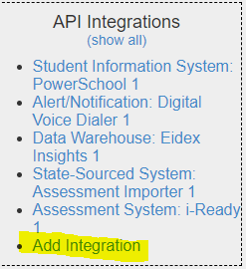
  - Enter the following values into the screen:
    - System Type: Assessment System
    - Vendor: Curriculum Associates
    - System: i-Ready
    - Profile: None
    - Leave any other options as they are.
  - Click on the submit button. You should return to the District Landing Page in the Data Hub Cockpit.
- From the District Landing Page, scroll to the bottom and confirm the API Integration has been created as Assessment System: i-Ready 1
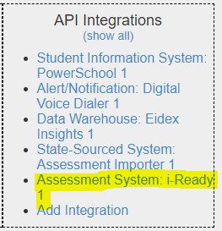
- Next, you will need to add back the EdFi core grade level descriptors. You should be able to do this by going into Utilities->Maintenance Scripts, then click on the "I-Ready Legacy Descriptor" radio button and click submit.
- Once the MiDataHub set up is complete, please notify your Partner Success Manager. It will take about 10-business days to turnaround the set up with i-Ready. Your Partner Success Manager will notify you when this has been completed.
- Upon set-up notification check to make sure that the results you expect are in the MiDataHub to confirm everything has been configured correctly. If you have an issue with the MiDataHub configuration, please reach out to MiDataHub Support (https://www.midatahub.org/support/)

