SAS® EVAAS
MiDataHub Data Configuration Guide and Requirements
Prepared for Michigan Department of Education

Contents
1 How to Use Configuration Guide 1
2 What is SAS EVAAS? 2
2.1 How does SAS use the student-teacher linkages in its teacher growth measures? 2
3 How to Create an EVAAS Integration and Opt-In to EVAAS Reporting 4
3.1 Verify if EVAAS Integration Already Exists 4
3.2 Create an EVAAS Integration 4
3.3 Submit Integration Credentials to EVAAS 5
3.3.1 Troubleshooting the Opt-In Process 6
3.4 Making Updates to an EVAAS Integration 6
4 EVAAS Data Requirements 7
4.1 Data Used for Teacher Reporting 7
4.1.1 Operational Data Store (ODS) School Year 7
4.1.2 Data Tables 7
4.1.3 Data Elements 9
4.1.4 Table-Specific Data Requirements 13
4.1.5 Cross-Table Data Requirements 14
5 How to Verify Data Completeness 16
5.1 School Data Load Analysis Report 16
5.2 At-A-Glance Report 16
5.3 SAS EVAAS Readiness Script 17
6 Data Validation Checklist 18
7 Common Questions 19

How to Use Configuration Guide
The purpose of this configuration guide is to support districts in Michigan that are opting in to receive EVAAS teacher reporting. This document also provides an overview of the EVAAS reporting that districts are opting in for. In addition, this guide contains detailed instructions on how to complete the opt-in process and verify that the data required for EVAAS teacher reporting is populated in Michigan Data Hub (MiDataHub) as expected. Refer to the Data Validation Checklist included at the end of this document to help keep track as steps are completed.

What is SAS EVAAS?
EVAAS provides measures of student growth for teachers, schools, and districts. These reports collectively provide personalized feedback to educators through a secure and interactive web application.
EVAAS uses teacher and student information in files from the MiDataHub to do the following:
- provide districts with teacher reporting based on state summative assessments
- where sufficient data exists, provide districts with student and/or teacher reporting based on additional assessments administered by districts
- create user accounts for teachers
- update student enrollment for student reports
For teacher reporting, SAS uses data from MiDataHub to link a student’s assessment to the teacher responsible for the student’s instruction. EVAAS links teachers to students’ test scores for the following state summative assessments:
- M-STEP Mathematics in grades 3-7 and M-STEP English Language Arts in grades 3-7
- PSAT 8/9 Mathematics in grade 8 and PSAT 8/9 English Language Arts in grade 8
SAS also receives benchmark assessments from districts that opt to submit them for EVAAS teacher reporting through the MiDataHub.
In prior years, the following assessments met the criteria for use in teacher value-added reporting:
- MAP Mathematics in grades 1–8 and MAP Reading in grades 1–8
- STAR Mathematics in grades 2-8 and STAR Reading and Literacy in grades K-8
- i-Ready Mathematics in grades K-8 and i-Ready ELA in grades K-8
To opt in for teacher reports and student enrollment updates, districts need to integrate their Student Information System with MiDataHub and submit student-teacher linkages from the most recent testing year along with student enrollment data for the current academic year.
EVAAS sends updates to district admins about due dates and other important information. After a district opts in, EVAAS provides teacher reporting and student enrollment updates unless the district opts out.

How does SAS use the student-teacher linkages in its teacher growth measures?
SAS uses the data elements captured from MiDataHub to provide teacher-level growth measures. These data elements identify which teachers were responsible for an individual student’s instruction as well as the teacher’s percentage of instructional responsibility for that student in the tested subjects and grades. The growth model uses this information to assess whether, on average, the students connected to a teacher tend to make more than, less than, or about expected growth. The growth model can also account for the patterns of influence that might exist across shared instructional practices when more than one teacher is responsible for a student’s instruction in a particular tested area, which is the case with team teaching or specialized instruction.
Teachers receive a growth measure only if sufficient data exists for each individual teacher regarding the number of students with a valid test score, prior test scores, and total percentage of instructional responsibility across all students linked to the teacher. The Statistical Models and Business Rules document provides details about the current MDE business rules.
Districts should follow the instructions in the subsequent sections to verify that the data required for EVAAS teacher reporting is populated in MiDataHub as expected.

How to Create an EVAAS Integration and Opt-In to EVAAS Reporting
The first step for a district to opt in to receive EVAAS teacher reports and student enrollment updates is setting up an EVAAS Integration in MiDataHub. Then, a district must provide EVAAS the credentials for the integration so that EVAAS gains access to the district’s data. A district is considered opted in once they have successfully submitted the key and secret for an active integration to EVAAS. The section outlines the steps for this process.

Verify if EVAAS Integration Already Exists
Districts can verify if the EVAAS integration is already active by logging in to the MiDataHub cockpit and navigating to the API Integration section located in the bottom right corner. If the integration exists, the district will see an entry labeled as “Data Warehouse: EVAAS 1” as shown in Figure 1 below. If the integration does not exist, please follow the instructions for creating the integration in section 3.2.
Figure 1: API Integrations with EVAAS Integration Active
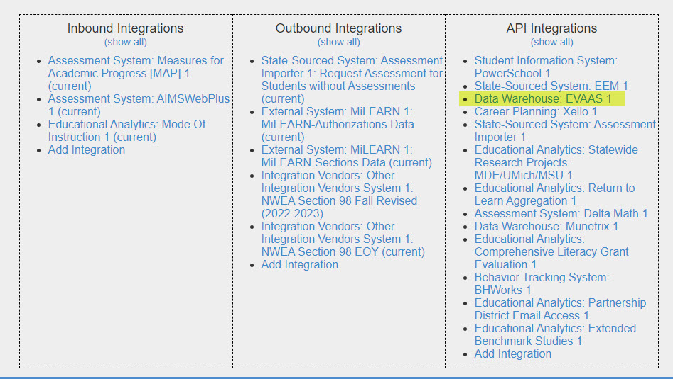

Create an EVAAS Integration
Follow the steps below to generate the API integration for the opt-in process. In addition to the written steps, a video tutorial is available as a walk-through for the process. Figure 2 shows an example of how the Manage API Integration page should look after the steps are completed:
- Log in to MiDataHub.
- Click on the name of the Independent School District (ISD) that your district is in and choose the name of your district to get to your district landing page.
- From your district landing page, scroll to the bottom right-hand corner of the screen and click "Add Integration" in the API Integration box.
- Enter the following choices and click the Submit Button.
  - System Type: Data Warehouse
  - Vendor: SAS Institute
  - System: EVAAS – v1
  - Allow UIC Auto Creation - Leave unchecked
- Scroll back down to the API Integrations area and click on the link labeled "Data Warehouse: EVAAS 1."
Select only the options listed above, make sure None is selected for the Profile drop-down, and that no additional check boxes are selected.
Figure 2: Sample Manage API Integration Screen
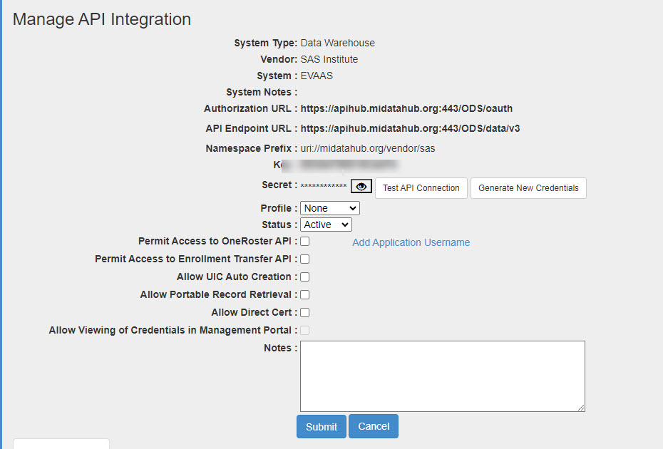

Submit Integration Credentials to EVAAS
A district’s key and secret are generated when the API integration has been created in the MiDataHub cockpit. To obtain the key and secret, navigate to the MiDataHub cockpit and select the EVAAS API integration. From there, the key and secret can be obtained and filled in this secure form to submit to EVAAS.

Troubleshooting the Opt-In Process
While completing the opt-in process, there are several feedback messages that might populate on the site. Table 1 lists possible feedback messages and the troubleshooting steps to complete in response.
Table 1: MiDataHub Opt in Feedback Messages
Message | Next Steps
Connection Error | Contact SAS EVAAS at evaas_support@sas.com
District Exists | Contact SAS EVAAS at evaas_support@sas.com
Invalid Entry | Contact SAS EVAAS at evaas_support@sas.com
Success | No further action is needed.
Your district opted-in previously, and no further action is required. | No further action is needed.
The key, secret, and/or URL provided do not match our records. Verify the information is entered correctly and does not contain extra characters or spaces. If connection issues continue, contact EVAAS Technical Support. | Send email to the MiDataHub support at support@midatahub.org.
Thank you for opting in. | No further action is needed.
SAS EVAAS is unable to verify your data. EVAAS or the MiDataHub support team will contact you if additional information is needed. | SAS EVAAS or the MiDataHub support team will contact you if additional information is needed.
If you are having difficulty completing the opt-in process, please contact EVAAS at evaas_support@sas.com with information about the error message and receive additional support.

Making Updates to an EVAAS Integration
EVAAS does not usually require a district to update their integration credentials once they have opted in. However, if a new key and secret are generated for an already existing integration, then the district needs to submit the updated key and secret through this secure form to EVAAS so that they can maintain access to the district’s data.

EVAAS Data Requirements
EVAAS utilizes data from several MiDataHub tables. Districts should review the tables and data elements used for different EVAAS workflows to understand if their data in MiDataHub meets EVAAS data requirements. This section details which tables are used for different EVAAS workflows as well as which data elements from each table are used.

Data Used for Teacher Reporting

Operational Data Store (ODS) School Year
EVAAS uses data from different ODS years depending on the use case for the data. For teacher reporting, EVAAS pulls data from the ODS of the most recently completed school year in MiDataHub. This data is most often pulled in the fall or winter months following the completion of testing for that year. Specific dates for when the data will be pulled are announced in yearly communications from EVAAS, at which time districts need to review the required data tables and data elements. When reviewing required data tables and data elements, districts should ensure they are validating data for the appropriate year in the MiDataHub cockpit.

Data Tables
EVAAS utilizes specific data tables to create student-teacher rosters to use in teacher reporting. Districts should verify the required data tables listed in Table 2 are not empty in the ODS for the most recent testing year.
Table 2: Data Table Requirements
Table | Requirement | Usage Notes
Staffs | Required | EVAAS uses staff name and identificationCode information from this table to identify a teacher’s state PIC to connect teacher data across time. EVAAS also uses email addresses from this table to create accounts for teachers. Details about required data elements for this data table are listed in Table 3 in section 4.1.3.
StaffSectionAssociations | Required | EVAAS combines this table with the StudentSectionAssociations table to create rosters that identify which teachers instructed which students in which course sections. Details about required data elements for this data table are listed in Table 4 in section 4.1.3.
ClassroomPositionDescriptors | Required | EVAAS combines this table with the StaffSectionAssociations table to identify which staff are “Teacher of Record” for a particular course section. Details about required data elements for this data table listed in Table 5 in section 4.1.3.
Students | Required | EVAAS uses student name and birthdate information from this table to identify students and help connect student data across time. Details about required data elements for this data table are listed in Table 6 in section 4.1.3.
StudentSectionAssociations | Required | EVAAS combines this table with the StaffSectionAssociations table to create rosters to identify which teachers instructed which students in which course sections. Details about required data elements for this data table are listed in Table 7 in section 4.1.3.
CourseOfferings | Required | EVAAS combines this table with the StaffSectionAssociations table and uses course titles from this table to identify which course sections provide instruction in which tested subjects for teacher reporting. Details about required data elements for this data table are listed in Table 8 in section 4.1.3.
Courses | Required | EVAAS combines this table with the CourseOfferings and AcademicSubjectDescriptors tables to provide additional information to help identify which course sections provide instruction in which tested subjects for teacher reporting. Details about required data elements for this data table are listed in Table 9 in section 4.1.3.
AcademicSubjectDescriptors | Required | EVAAS combines this table with the Courses table to help identify which courses provide instruction in which tested subjects for teacher reporting. Details about required data elements for this data table are listed in Table 10 in section 4.1.3.
StudentEducationOrganizationAssociations | Optional | EVAAS uses identificationCode information from this table to identify a student’s state UIC to help connect student data across time. Details about required data elements for this data table are listed in Table 11 in section 4.1.3.
Schools | Optional | EVAAS uses identificationCode information from this table to identify the 5-digit state school code associated with the schoolId in the StaffSectionAssociations and StudentSectionAssociations tables. Details about required data elements for this data table are listed in Table 12 in section 4.1.3.

Data Elements
EVAAS utilizes the following data elements from each table. Districts should verify required data elements identified in Tables 3-12 are not empty in the ODS for the most recent testing year.
Table 3: Staffs
Data Element | Requirement | Usage Notes
staffUniqueID | Required | Used to connect teacher information to StaffSectionAssociations table
firstName | Required | Used to identify teacher names
lastName | Required | Used to identify teacher names
middleName | Optional | Used to identify teacher names
electronicMails.electronicMailAddress | Required | Used to identify teacher email addresses to create EVAAS accounts
electronicMails.electronicMailTypeDescriptor | Required | Used to identify teacher email addresses to create EVAAS accounts
identificationCodes.staffIdentificationSystemDescriptor | Required | Used to identify a teacher’s state PIC to connect teacher data across time
identificationCodes.identificationCode | Required | Used to identify a teacher’s state PIC to connect teacher data across time
Table 4: StaffSectionAssociations
Data Element | Requirement | Usage Notes
classroomPositionDescriptor | Required | Used to connect to ClassroomPositionDescriptor table
staffReference.staffUniqueId | Required | Used to connect teacher information from Staffs table
sectionReference.localCourseCode | Required | Used to connect to StudentSectionAssociations and CourseOfferings tables
sectionReference.schoolID | Required | Used to connect to StudentSectionAssociations and CourseOfferings tables
sectionReference.schoolYear | Required | Used to connect to StudentSectionAssociations and CourseOfferings tables
sectionReference.sessionName | Required | Used to connect to StudentSectionAssociations and CourseOfferings tables
sectionReference.sectionIdentifier | Required | Used to connect to StudentSectionAssociations table
beginDate | Required | Used in conjunction with beginDates and endDates from the StudentSectionAssociations table to determine a teacher’s instructional responsibility for a student in a tested subject.
endDate | Required | Used in conjunction with beginDates and endDates from the StudentSectionAssociations table to determine a teacher’s instructional responsibility for a student in a tested subject.
teacherStudentDataLinkExclusion | Optional | Used to exclude entries from StaffSectionAssociations table
Table 5: ClassroomPositionDescriptors
Data Element | Requirement | Usage Notes
codeValue | Required | Used to connect to StaffSectionAssociations table
namespace | Required | Used to connect to StaffSectionAssociations table
shortDescription | Required | Used to identify the “Teacher of Record” for a section
Table 6: Students
Data Element | Requirement | Usage Notes
studentUniqueId | Required | Used to connect student information to StudentSectionAssociations table
birthdate | Required | Used to identify student information and connect student data across time
firstName | Required | Used to identify student information and connect student data across time
lastName | Required | Used to identify student information and connect student data across time
middleName | Optional | Used to identify student information and connect student data across time
Table 7: StudentSectionAssociations
Data Element | Requirement | Usage Notes
studentReference.studentUniqueId | Required | Used to connect student information from Students table
sectionReference.localCourseCode | Required | Used to connect to StaffSectionAssociations and CourseOfferings tables
sectionReference.schoolID | Required | Used to connect to StaffSectionAssociations and CourseOfferings tables
sectionReference.schoolYear | Required | Used to connect to StaffSectionAssociations and CourseOfferings tables
sectionReference.sessionName | Required | Used to connect to StaffSectionAssociations and CourseOfferings tables
sectionReference.sectionIdentifier | Required | Used to connect to StaffSectionAssociations table
beginDate | Required | Used in conjunction with beginDates and endDates from StaffSectionAssociations table to determine a teacher’s instructional responsibility for a student in a tested subject
endDate | Required | Used in conjunction with beginDates and endDates from StaffSectionAssociations table to determine a teacher’s instructional responsibility for a student in a tested subject
teacherStudentDataLinkExclusion | Optional | Used to exclude entries from StudentSectionAssociations table
Table 8: CourseOfferings
Data Element | Requirement | Usage Notes
localCourseTitle | Required | Used to identify course sections associated with tested subjects (English Language Arts, Mathematics, Reading)
localCourseCode | Required | Used to connect to StaffSectionAssociations table
schoolReference.schoolId | Required | Used to connect to StaffSectionAssociations table
sessionReference.sessionSchoolID | Required | Used to connect to StaffSectionAssociations table
sessionReference.schoolYear | Required | Used to connect to StaffSectionAssociations table
sessionReference.sessionName | Required | Used to connect to StaffSectionAssociations table
courseReference.courseCode | Required | Used to connect to Courses table
courseReference.educationOrganizationId | Required | Used to connect to Courses table
Table 9: Courses
Data Element | Requirement | Usage Notes
courseTitle | Required | Used to identify course sections associated with tested subjects (English Language Arts, Mathematics, Reading)
courseCode | Required | Used to connect to CourseOfferings table
educationOrganizationId | Required | Used to connect to CourseOfferings table
academicSubjectDescriptor | Optional | Used to connect to AcademicSubjectDescriptor table
Table 10: AcademicSubjectDescriptors
Data Element | Requirement | Usage Notes
codeValue | Required | Used to connect to Courses table
namespace | Required | Used to connect to Courses table
description | Required | Used as additional information to help identify course sections associated with tested subjects (English Language Arts, Mathematics, Reading)
Table 11: StudentEducationOrganizationAssocations
Data Element | Requirement | Usage Notes
studentReference.studentUniqueId | Optional | Used to connect to Students table
identificationCodes.studentidentificationSystemDescriptor | Optional | Used to identify a student’s state UIC to help connect student data across time
identificationCodes.identificationCode | Optional | Used to identify a student’s state UIC to help connect student data across time
Table 12: Schools
Data Element | Requirement | Usage Notes
schoolId | Optional | Used to connect to StaffSectionAssociations table
identificationCodes.educationOrganizationSystemDescriptor | Optional | Used to identify the 5-digit state school code associated with the schoolId in the StaffSectionAssociations table
identificationCodes.identificationCode | Optional | Used to identify the 5-digit state school code associated with the schoolId in the StaffSectionAssociations table

Table-Specific Data Requirements
This section outlines how different data elements are used and what exclusions are applied. Based on this information, districts should verify a large proportion of their data is not unusable based on business rules identified here.

Courses for Relevant Tested Subjects Must Exist in the CourseOfferings Table
EVAAS is providing teacher reporting for English Language Arts, Mathematics, and Reading subjects in grades K-8. If a district does not provide any variations of these subjects, then rostering data is not complete for the district.
EVAAS does allow “self-contained” courses to be used for teacher reporting if there are no other courses that explicitly contain the relevant subjects within their course name that connect to the assessments initially. Some examples of these courses are “1st Grade,” “2nd Gr Homeroom,” and “3rd Grade Am Attendance.”

Valid PICs for Teacher Must Exist in the Staffs Table
EVAAS excludes records from the Staffs table with PICs that do not meet the state defined digit range and that are not numeric. Records with PICs of zero (0) will also be excluded.

Valid Teacher Names Must Exist in the Staffs Table
EVAAS excludes Staff records where teacher names that contain variations of “DO NOT USE,” “DELETE,” etc. In addition, EVAAS excludes Staff records where teacher names do not appear to uniquely identify a teacher, such as multiple teachers being represented in a single record as co-teachers (in other words firstName = “John / Larry”, lastName = “Smith / Tanner”). When this happens, EVAAS cannot clearly discern which teacher the PIC belongs to. If multiple teachers provide instruction to a course section, districts should ensure that each teacher has a unique PIC in the Staffs table. These PICs should then exist as separate entries in the StaffSectionAssociations table connected to records for the course section.

Valid Teacher Email Addresses Must Exist in the Staffs Table
EVAAS utilizes teacher email addresses to set up accounts for teachers to access the EVAAS web application and to send communications to users. It is not a concern if only a handful of teacher email addresses are missing. If the electronicMailAddress is missing for most or all teachers in a district, then E from creating accounts for teachers in the district.

Data Elements beginDates and endDates Must be Populated in the StaffSectionAssociations and StudentSectionAssociations Tables
EVAAS uses beginDates and endDates to determine a teacher’s instructional responsibility for a student in a tested subject. Roster records where both student and staff beginDates and endDates are missing will be excluded.

Cross-Table Data Requirements
To create roster records that identify which teacher provided instruction to which students, in which tested subjects throughout the school year, EVAAS combines data elements from multiple tables (or endpoints). For a complete roster record to be created, data must exist across multiple tables.
Districts should review the tables and data elements used to join tables together to ensure all the expected data exists across all tables to create a complete roster record.

Sections Must Exist in both the StudentSectionAssociations and StaffSectionAssociations Tables
The course section information provided in the “StudentSectionAssociations” table should have connecting course section information present in the “StaffSectionAssociations” table so that teachers and student information can be connected to create a complete record that identifies which students a teacher provided instruction for in which sections.

Data Element staffUniqueId Must Exist in both the Staffs and StaffSectionAssociations Tables
EVAAS connects data from the “Staffs” table and “StaffSectionAssociations” table using staffUniqueId. If a staffUniqueId is present in one table and not the other, then the record is incomplete and will be excluded.

Courses from the StaffSectionAssociations and StudentSectionAssociations Tables Must Exist in the CourseOfferings or Courses Tables
The course information present in the “StudentSectionAssociations” and “StaffSectionAssociations” tables, must have an identifiable course name within the “CourseOfferings” or “Courses” tables.

Data Element studentUniqueId Must Exist in both the Student and StudentSectionAssociations Tables
EVAAS connects data from the “Students” table and the “StudentSectionAssociations” table using studentUniqueId. If a studentUniqueId is present in one table and not the other, then the record is incomplete and will be excluded.

How to Verify Data Completeness
There are multiple reports available in the MiDataHub cockpit that an individual with access as a Technical Contact can generate to understand the completeness of data in an ODS. A few examples of these reports are below.

School Data Load Analysis Report
This report provides a breakdown of data loaded in several categories for each school building including student along with staff counts, sections, staff and student sections, attendance, discipline, grades, sessions, and more. For EVAAS teacher reporting, districts should ensure the counts of data loaded for StudentEnrollments, StudentSection, StaffSection, StaffAssigned, and CourseOffering look reasonable for schools that provide instruction for grades K-8.
Figure 3: Sample School Data Load Analysis Report

At-A-Glance Report
The At-A-Glance Report in the MiDataHub cockpit provides data counts on FTE (District, Grade Level, Building), Race/Ethnicity, Courses, Attendance (Section, Daily), Grades (Transcript, term), and discipline.
This report, as pictured in Figure 4, provides end users with the number of students who don’t have a student section (and staff association) in the MiDataHub cockpit. Upon configuring this report, if there are any enrolled students missing, then these associations will show up in the enrolled column. More details about interpreting this report can be found in the MiDataHub At-A-Glance Report document. If you need any assistance with this report, please send an email to support@midatahub.org.
Figure 4: Sample At-A-Glance Report
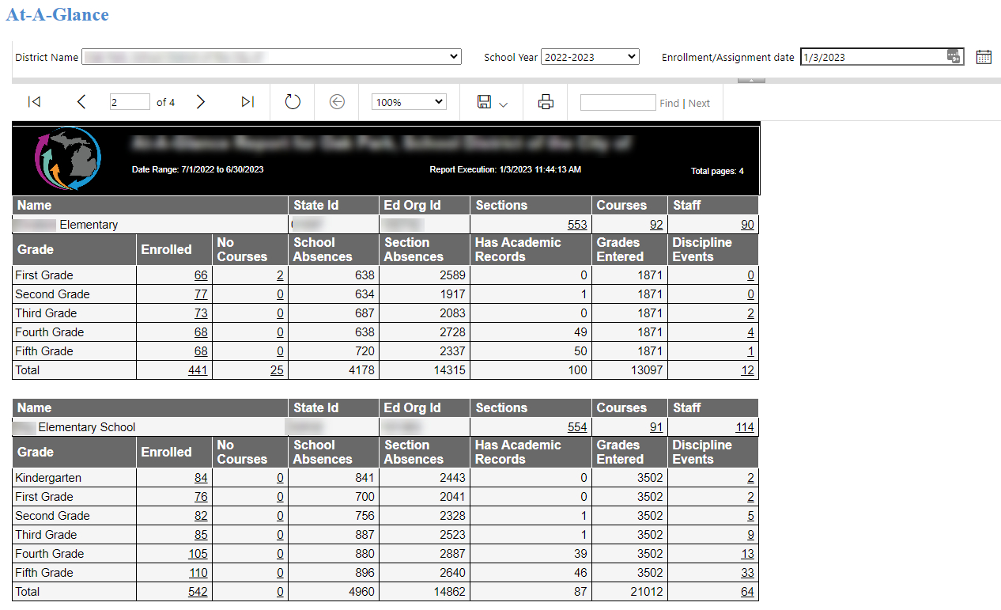

SAS EVAAS Readiness Script
The SAS EVAAS Readiness Script was designed to identify a district’s readiness level to receive teacher reporting. It includes a series of data validation checks to provide information around data missingness for a district to determine potential areas to address with their SIS vendor and MiDataHub. Follow the video tutorial for steps on how to use the script.
The video tutorial uses 2018-2019 ODS year for demonstration only. Districts should use the most recently completed school year’s ODS when running this script.

Data Validation Checklist
- Opt In to EVAAS Reporting
  - Verify if EVAAS integration already exists.
  - Create an EVAAS integration (if it does not already exist)
  - Provide EVAAS with integration credentials.
- Verify Data Required for Teacher Reporting is Present and Complete in ODS for most recently completed school year.
  - Review tables required for EVAAS Teacher Reporting
  - Verify that required tables are not empty.
    - If empty, work with SIS vendor to add missing data to MiDataHub ODS
  - Verify required data elements from required tables are not missing.
    - If data is incomplete, work with SIS vendor to add missing data to MiDataHub ODS
  - Verify counts of data loaded into ODS appears reasonable based on district expectations.
    - Verify count of teachers in Staffs looks reasonable.
    - Verify count of teachers in StaffSectionAssociations looks reasonable.
    - Verify that course sections exist in both StaffSectionAssociations and StudentSectionAssociations for course sections that provide instruction for English Language Arts, Mathematics, and Reading in grades K-8.
    - Verify count of students in Students looks reasonable.
    - Verify count of students in StudentSectionAssociations looks reasonable.
    - Verify count of courses in CourseOfferings that are a variation of an English Language Arts, Mathematics, or Reading course looks reasonable.

Common Questions
- What happens if the “Add integration” box is unavailable?
  - The “Add Integration” link is available for users with an authorization of a Technical Contact in the MiDataHub cockpit. MiDataHub recommends working with a user listed as a Technical Contact to configure the API. If you need assistance with determining who these individuals are for your district please email support@midatahub.org.
- Can you please confirm that the data is transferring?
  - EVAAS can verify that the district has completed the opt-in process and is potentially eligible for teacher level reporting. The data will not be processed until the opt-in window closes. EVAAS highly recommends reviewing the current state of data that resides in the MiDataHub cockpit as we will process the API pull from MiDataHub after the opt-in window closes. Please review section 5 of this document to verify that your data is available in the ODS.
- What is the cost of teacher reporting?
  - EVAAS reports are free to districts through a partnership with the Michigan Department of Education and MiDataHub. These reports can help teachers reflect on how the program and instruction are supporting the academic growth of all students, and this information is useful to educators even in cases where student growth data is not used in educator evaluations.
- My district has opted in. What should I expect next?
  - Once the opt-in process is completed, a message stating “Success” will populate. Next, districts will need to ensure the data supplied is correct, by using the Data Validation Checklist. Finally, EVAAS will send emails prior to the release of teacher reporting to notify districts of the pending release.

