

# Integrating G Suite SAML Applications with MiDataHub

# Purpose of the Document

The following instructional will provide the end user steps to configure the single sign-on federation with MiDataHub (MiLaunchPad), within G-Suite

# **Step 1:** Log in to GSuite as an administrative user.

**Step 2:** Locate, and select the Apps icon from the dashboard:

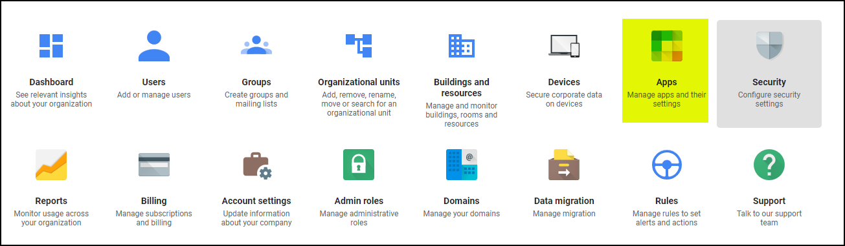

**Step 3:** Locate, and select the SAML Apps icon:

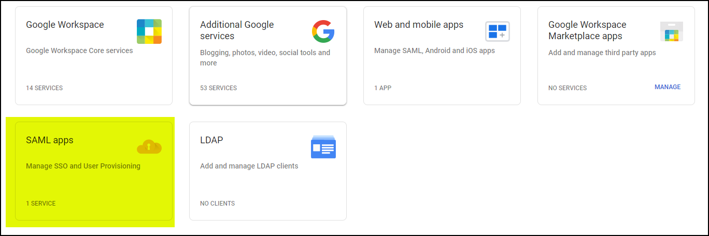

**Step 4:** Click the Add App link, and select Add Custom SAML App:

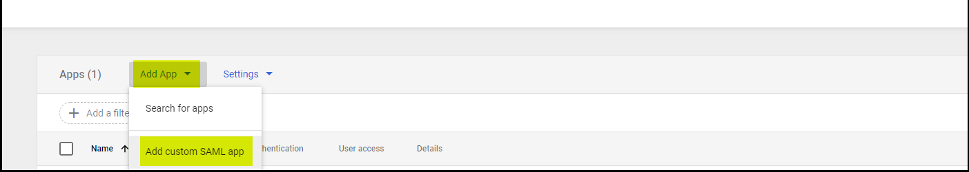

**Step 5:** Add the name of app, suggest using MiDataHub, click Continue:

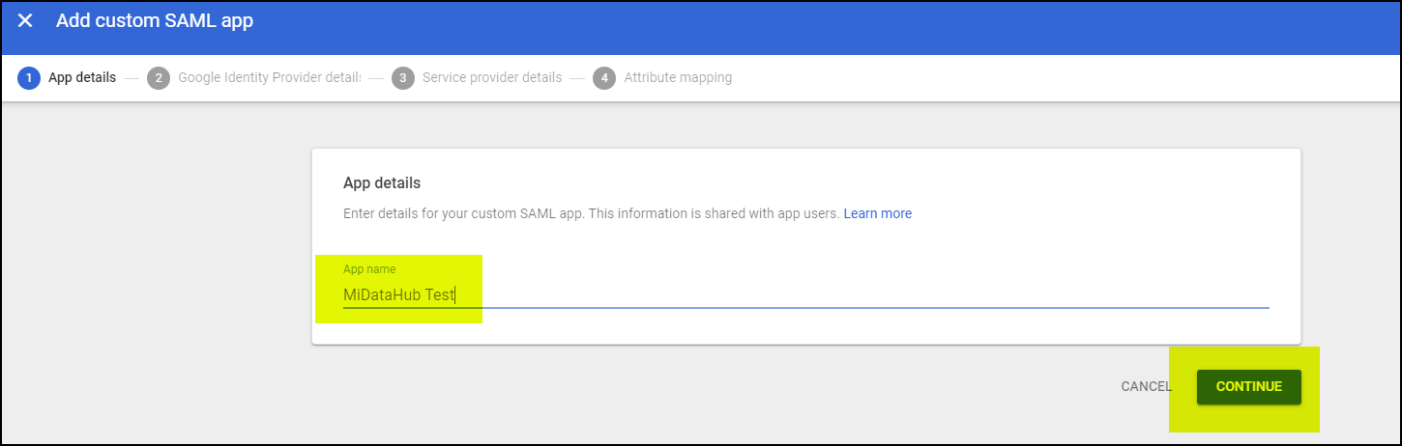

**Step 6:** At this point, your able to provide the IdP MetaDatafile to the team at MiDataHub for processing. There are two options available to provide your MetaData file to the Hub.

* Email the MetaData file to [support@midatahub.org](mailto:support@midatahub.org)
* Add to the district folder in the MiDataHub Cockpit, and notifying us by sending an email to [support@midatahub.org](mailto:support@midatahub.org) including all the details (school district, etc.)

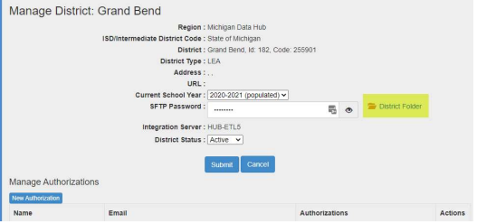

***Please note you can proceed forward with the following steps before submitting the file. After downloading the file, please continue forward by clicking continue:

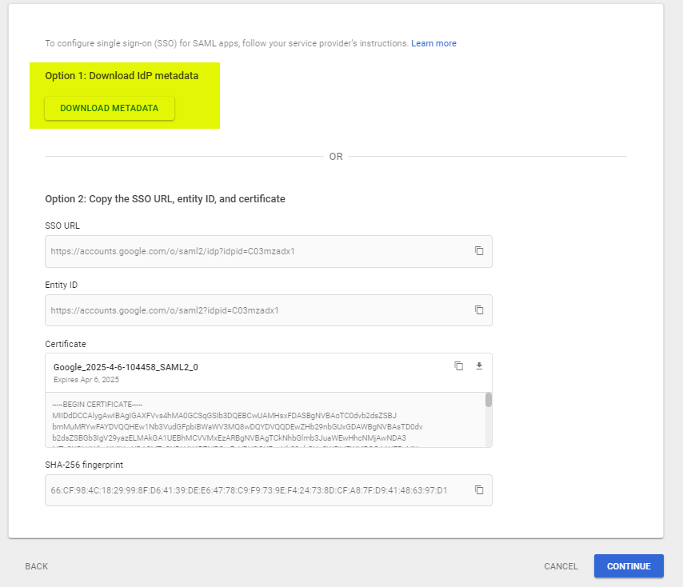

**Step 7:** Please enter information into the highlighted areas below. (Please double check for additional spaces after and before each URL entry below. If the “continue” button is greyed out this could be the reason.):

ACS URL:**https://adfs.midatahub.org/adfs/ls/**

Entity ID: **http://adfs.midatahub.org/adfs/services/trust**

Name ID Format: select WIN_DOMAIN_QUALIFIED

Name ID: select **Basic Information** and **Primary Email**

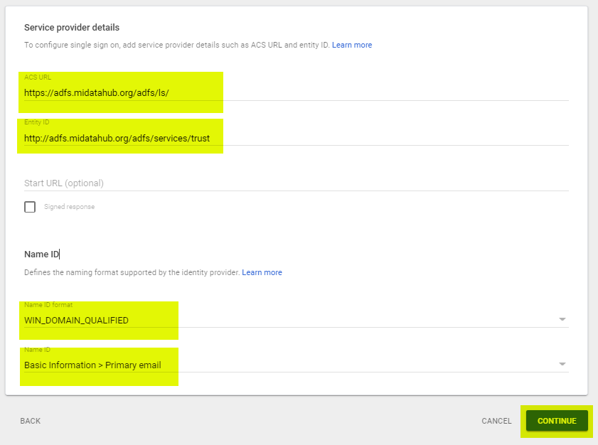

**Step 8:** Click Add Mapping

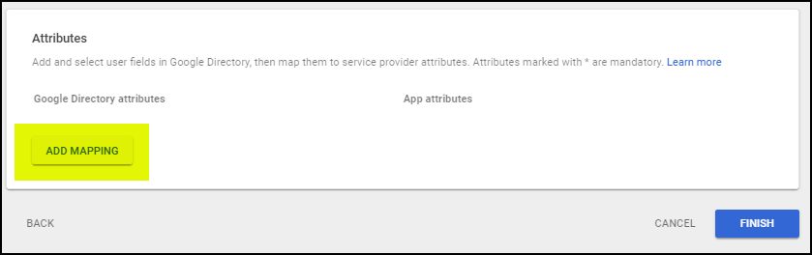

**Step 9:** Enter the following selections on this screen, when done click finish:

Basic Information: select Primary Email

App Attributes:http://schemas.xmlsoap.org/ws/2005/05/identity/claims/emailaddress

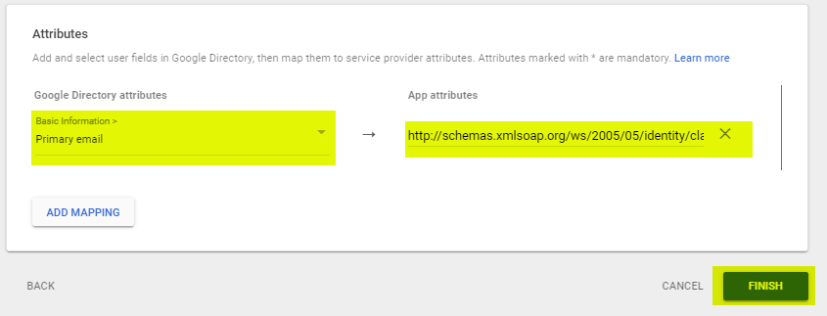

**Step 10**: Select the Apps icon from the main dashboard:



**Step 11:** Click on SAML Apps:



**Step 12:** Click anywhere in the row labeled the name associated with your newly created SAML app for the federation with MiDataHub:

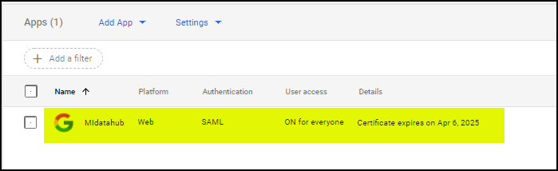

**Step 13:** Select the User Access box to ensure this is ON for everyone.

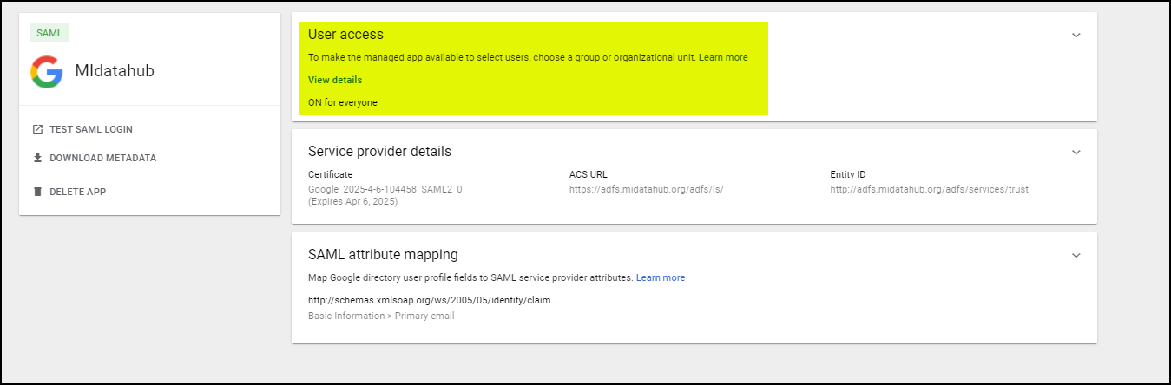

**Step 14:** Select **ON for everyone** and click save. (This setting could take up to 24 hours to take full effect in G Suite.):

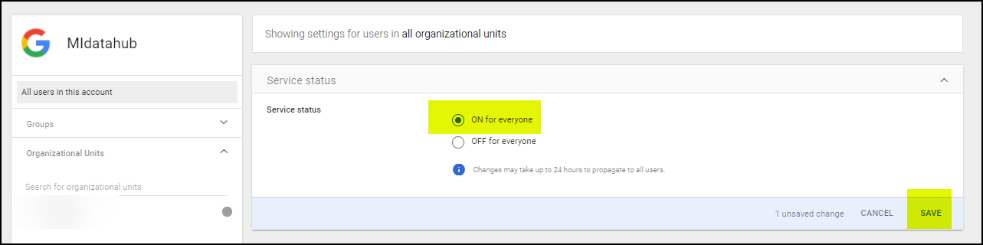

If you have any issues while working through this please email [support@midatahub.org](mailto:support@midatahub.org) for assistance.