MiDataHub – Configuring i-Ready for Assessment Results
The i-Ready integration consists of an API Integration, which allows for the pulling of the roster data and the sending of assessment (diagnostic) results back to MiDataHub via the Ed-Fi API. Below are the configuration steps for those pieces.

- Reach out to your Curriculum Associates Account Manager (Deonna Starks) and notify them you are interested in having diagnostic results from i-Ready sent to the MiDataHub.
Curriculum Associates has partnered with Microsoft to be able to send diagnostic results to the MiDataHub. For Curriculum Associates to share this data with Microsoft, the district must sign a data sharing agreement which allows Microsoft to access the diagnostic and roster data.
Your Account Manager will send you this agreement. Once it’s signed and returned you will receive a confirmation via SecureMail. Keep your login information for this interface as you will use SecureMail to send us the API key and secret (more on this in upcoming steps).
Please note exports will be weekly unless designated otherwise.
- Confirm Roster and Class Enrollment Data are in the MiDataHub. MiDataHub Support (https://www.midatahub.org/support/) can assist if you have questions about how to do this.
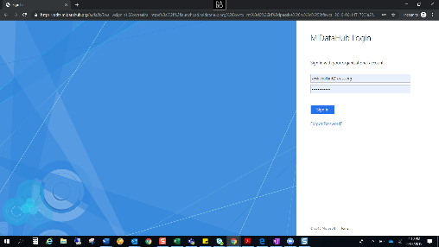
- Configuring the MiDataHub:
  - log into the cockpit by selecting the “LOG IN” button found at the top of the screen at www.midatahub.org or by clicking here.
  - Navigate to your district page.
  - Scroll down to the bottom of the screen and look at the API Integrations to see if a suitable integration has already been created (Assessment System: i-Ready 1). If so, continue to the steps for Sending Your Secure Information to Curriculum Associates (Step 4).
  - Click on the link to Add Integration in the API Integrations section
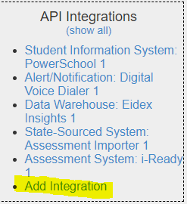
  - Enter the following values into the screen:
    - System Type: Assessment System
    - Vendor: Curriculum Associates
    - System: i-Ready
    - Profile: None
    - Leave any other options as they are.
  - Click on the submit button. You should return to the District Landing Page in the Data Hub Cockpit.
- From the District Landing Page, scroll to the bottom and click on the API Integration labeled as Assessment System: i-Ready 1
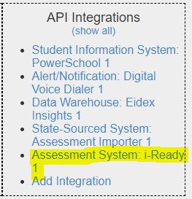
- From this screen, you will see the following values from the Source section, which you will need to cut and paste into an email using our SecureMail site (https://securemail.cainc.com/webclient/Login.xhtml) referenced in step 1:
  - Authorization URL
  - API Endpoint URL
  - Key
  - Secret (Click the eye symbol to unmask first)
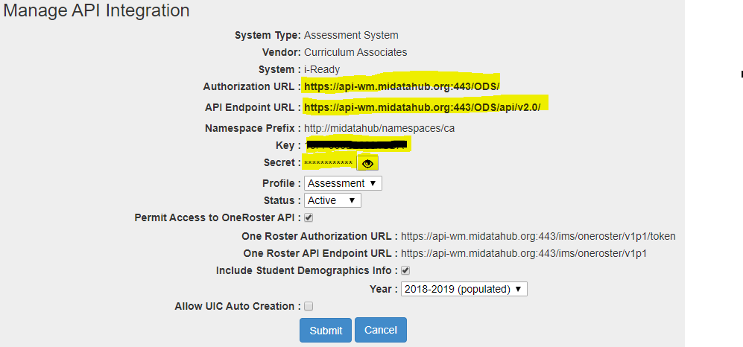
- Select Cancel to return to the District Landing Page
- Once the key and secret are received there will be a 10-business day turnaround for the set up. Your Account Manager will notify you when this has been completed.
- Upon set-up notification check to make sure that the results you expect are in the MiDataHub to confirm everything has been configured correctly. If you have an issue with the configuration, please reach out to MiDataHub Support (https://www.midatahub.org/support/)

