- Login in to azure portal.
- Select azure active directory.
- Select enterprise applications.
- Select Michigan Data Hub Single Sign on application.
- Select set up single sign on
- Under the section labeled SAML certificates select edit

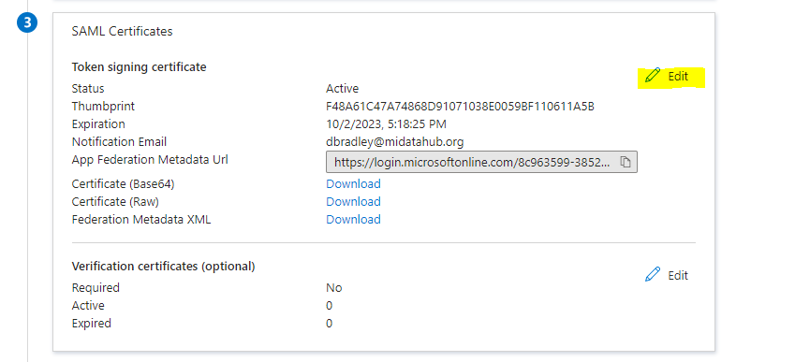
- On the SAML Singing Certificate flyout menu select + new certificate

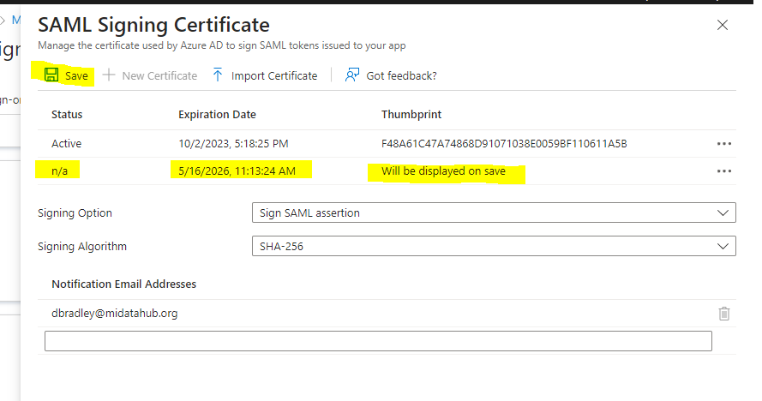
- You can make the new certificate active immediately, this should happen automatically when the prior cert expires so this step is optional. If you make it active immediately it won’t be pulled into the hubs SSO until the nightly job runs or a request, through the ticket system, is made for immediate update.
- On the next federation metadata update the cert will be pulled over:
