Steps taken by the district in Azure Active Directory to federate with the MI Datahub:
- Login into the Azure portal as an admin

- From the home screen, select Azure Active Directory
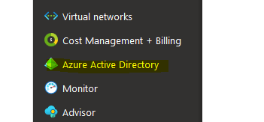
- From the fly-out menu select Enterprise applications

- Select + new Application at the top and you will be presented with the following:

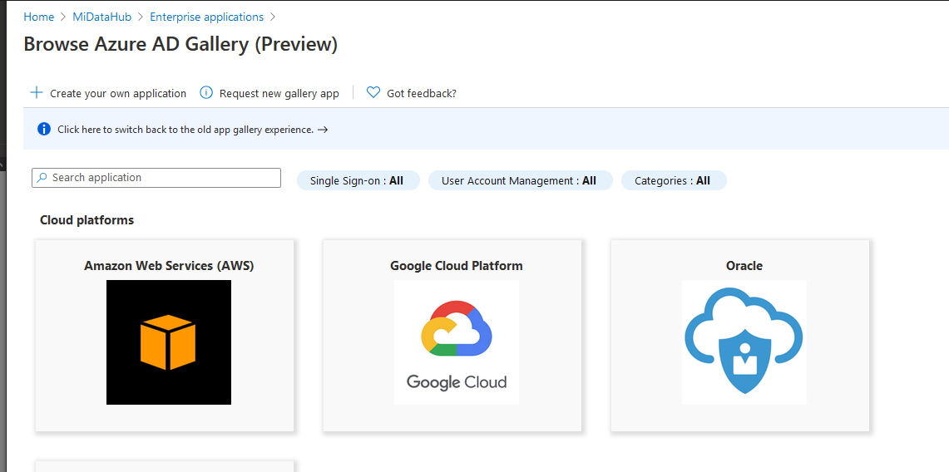

- In the search application box type Michigan Data Hub and you will be presented with:
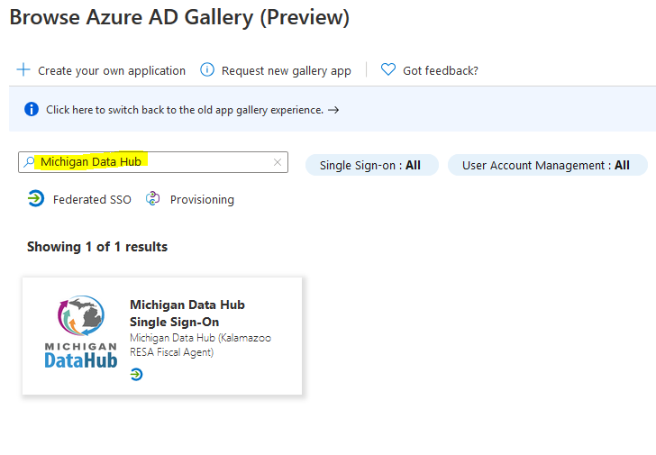
- Select The application and on the flyout menu select create:
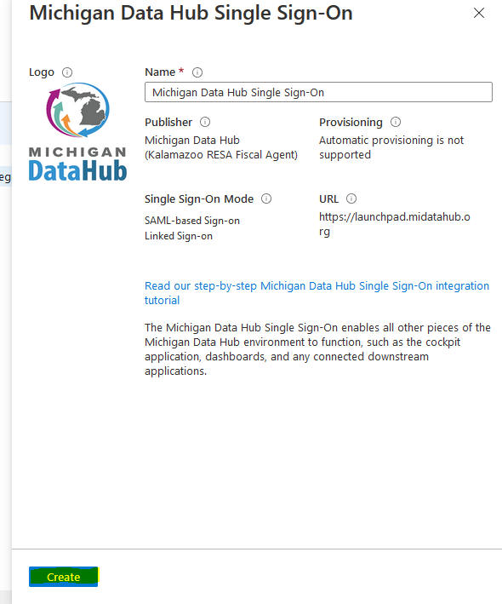
- Once the application is created it will need to be configured. if you are not presented with the configuration screen return to enterprise applications and use the search box to find the newly created application:

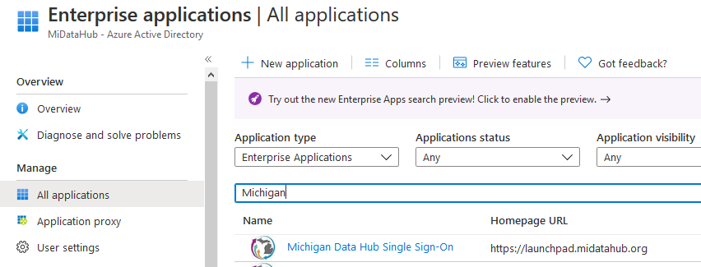

- From the properties page select Set up single sign on:
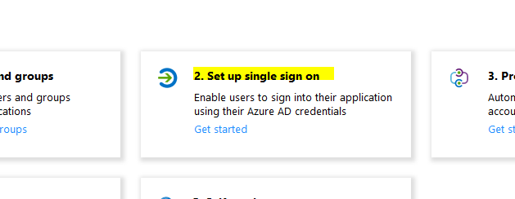
- In the Select a single sign-on method select SAML:
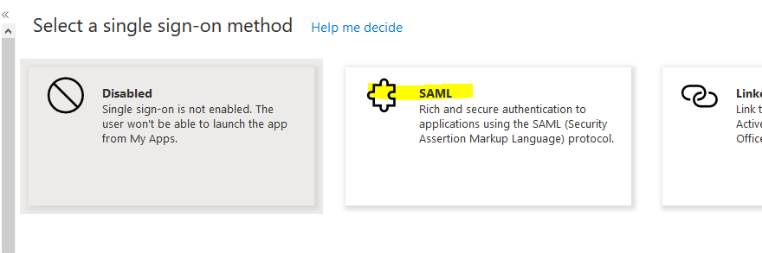
- You be presented with the following:
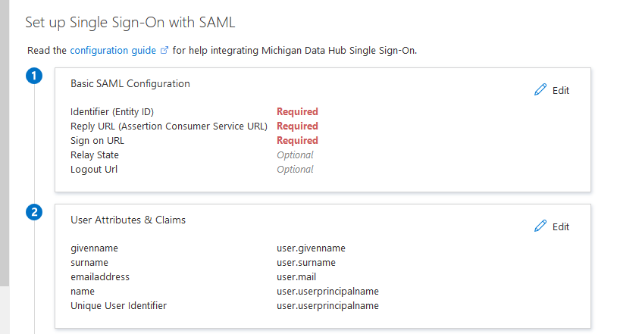
- Select edit in the basic SAML configuration section and you will be presented with the following:
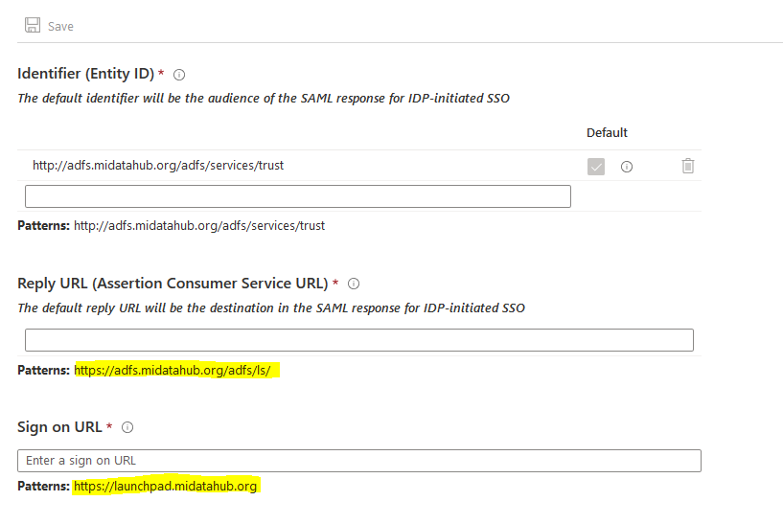

- Copy the values in patterns section for Reply url and sign on url into their corresponding textbox and select save. Your page should look like this:
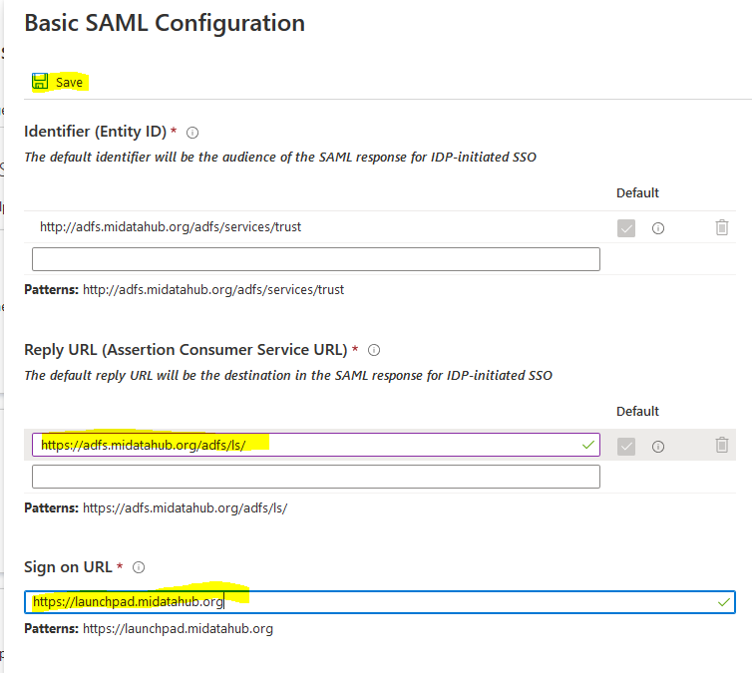

- Once saved the basic SAML configuration should look like this:
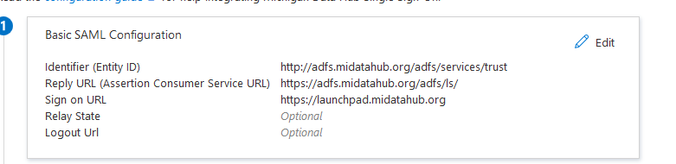

- Please leave the User Attributes & Claims (section 2) as the presented values. Only edit this section if your district is using a non-standard field to hold email address. If a non-standard field is being used for email then it will need to be added here and the field name containing email address will need to be passed on to MiDataHub support.

- In Section 3 of the Set up Single Sign-On with SAML select the copy link for the App Federation Metadata URL. This URL needs to be sent to MiDataHub support for use in the federation in our SSO.
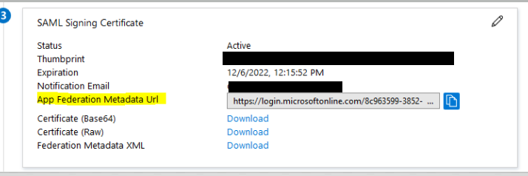
- To configure access for users to use the federated login select properties from the left menu:
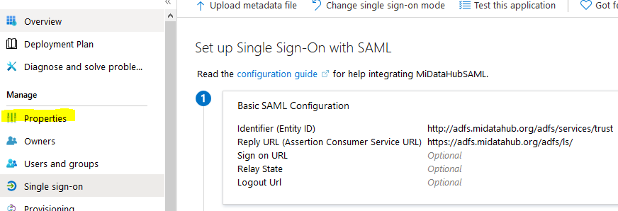

- Toggle User assignment required to No and Save at the top, this will give all users in your domain access to use the federated login.
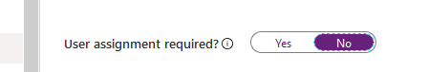
*Alternatively, users and or groups can be assigned access. A group such as Staff or an individual can be assigned to narrow access using the Users and Groups link.
- Once MiDataHub support has indicated your district has been federated please do the following to confirm proper access:
  - Navigate to Launchpad.midatahub.org in an InPrivate/Incognito or cookie-less browser
  - Select your district from the identity providers:
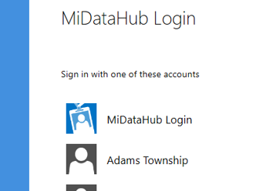
  - You will be directed to your Microsoft login screen to enter your Microsoft domain credentials
  - Once authenticated you will be redirected by to the Launchpad. You’ll know you’re successful if the following screen is presented with your district’s email:
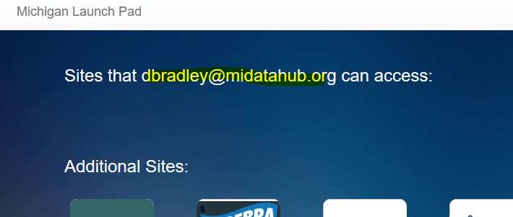

  - Any sites you have access to, based on the email address, will appear as application tiles in the Launchpad.

