Steps to be taken by the district in Azure Active Directory:
- Login into the Azure portal as an admin
- From the home screen select Azure Active Directory
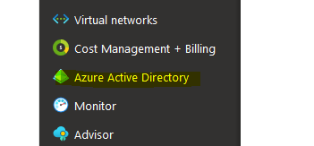
- From the fly-out menu select Enterprise applications
- Select + new Application at the top and you’ll be presented with the following:
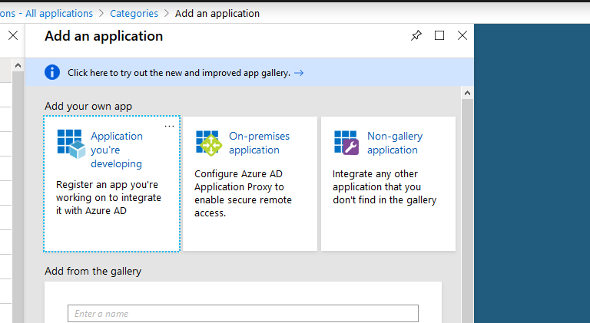

- Select Non-gallery application, give your application a name and select save at the bottom of the menu:
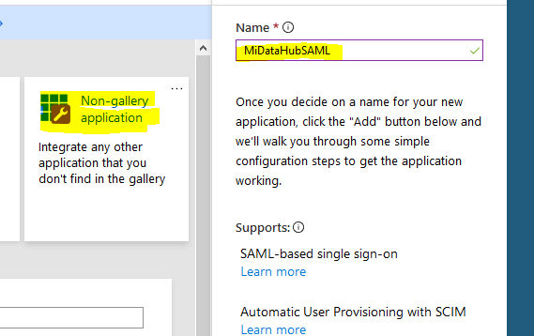
- From the add application page select Set up single sign on:
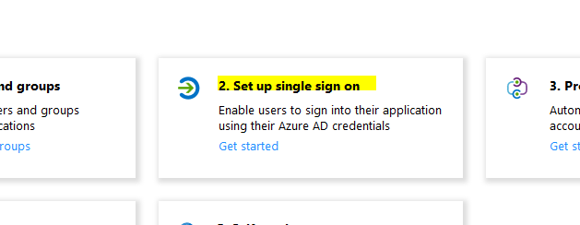

- In the first section of the Set up Single Sign-on with SAML enter
Identity: http://adfs.midatahub.org/adfs/services/trust
Reply URL: https://adfs.midatahub.org/adfs/ls/
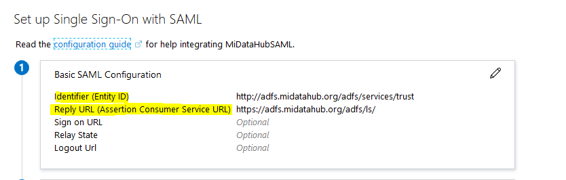
By selecting the pencil icon and filling in the URLs on the Basic SAML Configuration page and selecting save:
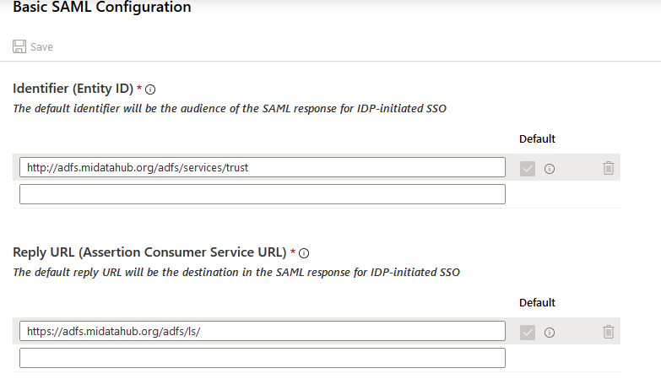

- Please leave the User Attributes & Claims in section 2 as standard, unless your district is using a non-standard field to hold email address. If a non-standard field is being used for email then it will need to be added here and the field name containing email address will need to be passed on to MiDataHub support.
- In Section 3 of the Set up Single Sign-On with SAML select the copy link for the App Federation Metadata URL. This URL needs to be sent to MiDataHub support for use in the federation in our SSO.
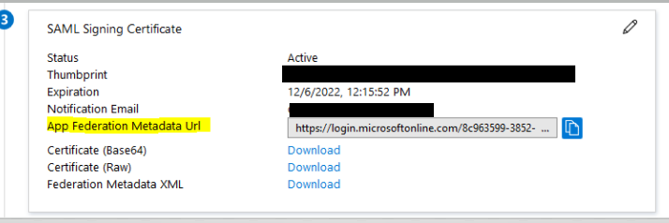
- In the left flyout menu select properties:
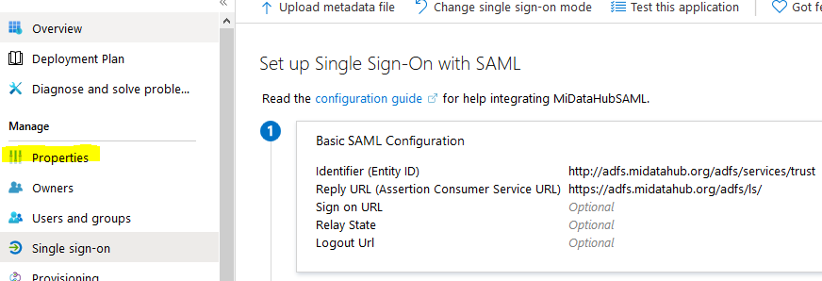

- Toggle User assignment required to No and Save at the top:
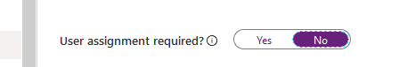
*Alternatively, users and or groups can be assigned access. The above setting will allow any user in your Azure AD to login into the SSO. A group such as Staff could be assigned to narrow access using the Users and Groups link.
- Once MiDataHub support has indicated your district has been federated please do the following to confirm proper access:
  - Navigate to Launchpad.midatahub.org in an InPrivate/Incognito or cookie-less browser
  - Select your district from the identity providers:
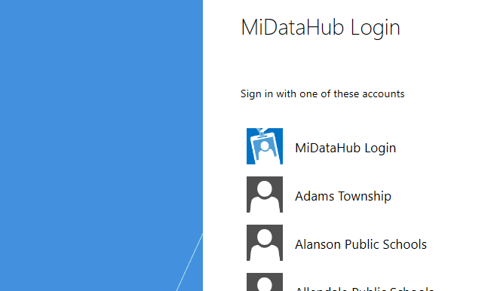
  - You’ll be directed to your Microsoft login screen to enter your Microsoft credentials
  - You should be redirected by to the Launchpad as authenticated. You’ll know you’re successful if the following screen is presented with your district’s email:
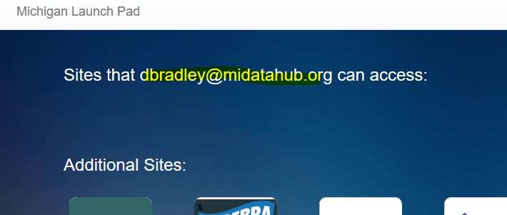

  - Any sites you have access to, based on the email address, will appear as application tiles in the Launchpad.

