The At-A-Glance Report in the MiDataHub cockpit provides aggregated data counts on building and district level data. Data counts on FTE (District, Grade Level, Building), Racial/Ethnicity, Courses, Attendance (Section, Daily), Grades (Transcript, term), and discipline.
- Login to the Michigan Data Hub Cockpit and select Reports> View District Reports

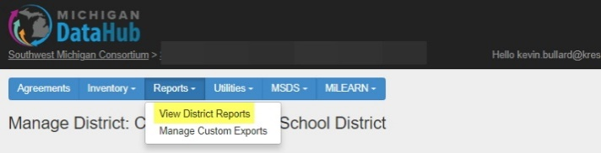

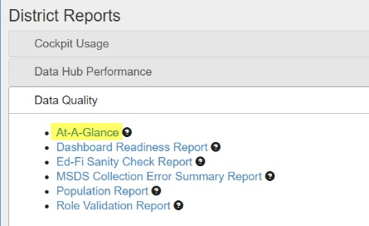
- Select Data Quality > At-A-Glance Report

- The screen below is what the report will look like upon configuring
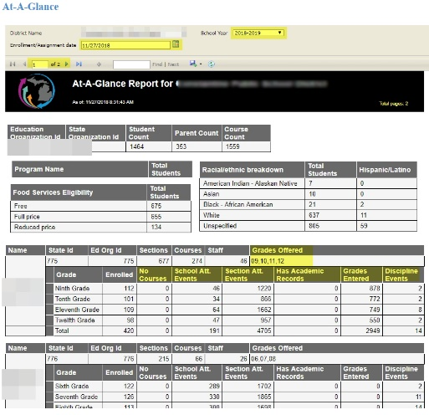

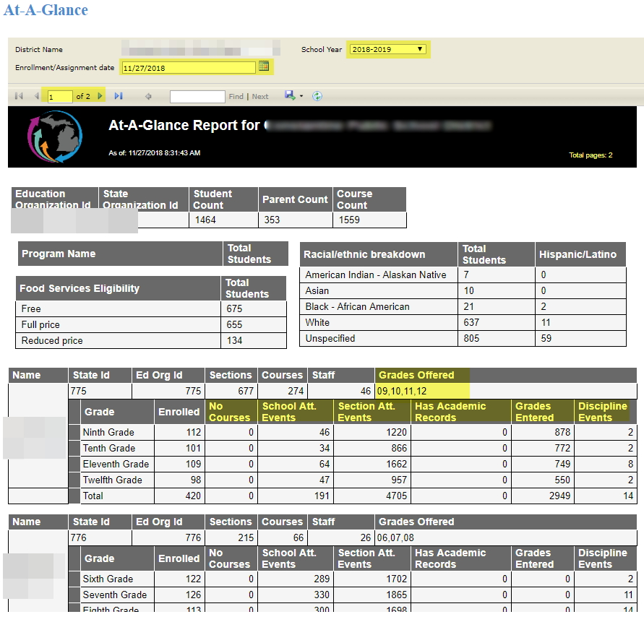
Please note the highlighted items (and other areas) in the screenshots above:
Data on this report is indicative of the data published from your Student Information System (SIS). If there are any questions on the numbers being either too high or low in categories as the ones mentioned below, please review the data being published from your SIS.
School Year: Select the correct school year you would like to see data reported
Enrollment/Assignment: Use the Enrollment/Assignment Date if you would like to filter the results by a specific date of enrollment. Example, if you would like to see the counts of students on June 6, 2018 (Make sure to select the 2017-18 school year in the school year pull down), it would be recommended to have accurate results to populate the Enrollment/Assignment Date to 6/6/2018.

Navigation Arrows: Varying on the size of your district, there could be multiple pages of building data available to view in this report. If there are multiple pages in the report, use the available directional arrows to navigate between each page.
Student Count: The number of students indicated in this field might vary from the current enrollment of students reflected in your SIS for your district. The student counts field indicates the total number of unique students in the district only. As a viewer of this report if you were to total the number of students on the report for each school you will most likely get a higher number of students that’s indicated in the student count field. This is mainly due to some students having concurrent enrollments in more than one school (as an example a MS student taking an HS course).
Grades Offered: These are the grades offered in the building they are included with.
No Courses: This column will show how many students are missing their course enrollments. If the number is zero than there are no students missing courses. If there is a number greater than 1, that signifies the number of students missing their course enrollments.

School Attendance Events: This column shows the number of daily attendance events posted to your Data Hub from the SIS. If this number seems low based on the number of days attendance has been taken for your district it is recommended to verify the attendance has been published to your data hub.
Section Attendance Events: The number of section attendance events posted to your Data Hub from the SIS. If this number seems low based on the number of days attendance has been taken for your district it is recommended to verify the attendance has been published to your data hub.
Has Academic Records: The number of academic marks posted to Transcript for the group of students represented in that row, at the building level. If the number is relatively low, please review the data being published from your SIS.
Grades Entered: The number of academic marks posted to terms (report cards) for the group of students represented in that row, at the building level. If the number is relatively low, please review the data being published from your Student Information System.
Discipline Events: The number of Discipline Events posted to your Data Hub from the SIS. Most SIS tools are currently only sending over state reportable offenses. If the number is relatively low, please review the data being published from your SIS.

