Dashboard Photo Management

Table of Contents
1. How to Upload Dashboard Photos 3
2. Prepare Image Files 3
2.1. Student 3
2.2. Staff 3
2.3. School 3
2.4. Local Education Agency 3
3. Upload Structure 4
4. Prepare for Upload 4
5. Upload Images 5
6. Technical Notes 6
6.1. ID Lookup Tables 6
6.2. IIS & Image Caching 7

How to Upload Dashboard Photos

This document outlines the recommended process for uploading images. This process should be used for Students, Staff, School, and Local Education Agency photos.
Photos for students and staff are uploaded in a single package per school. Photos for schools and a single local education agency are uploaded in a single package per local education agency.

Prepare Image Files

All images should be sized in a 3:4 ratio which is the standard size for yearbook photos.
Note: Logos for schools and local education agencies may need to be adjusted to fit these dimensions.
All images must be in one of the three following formats: .jpg, .jpeg, .png. Images in any other format will be ignored.

Student
Image files need to be named using the local student USI. For example, John Smith is a student and has a student USI of 12345689, his image file should be named 12345689.jpg.

Staff
Image files need to be named using the local staff USI. For example, Jane Smith is a staff member and has a staff USI of 987654321, her image file should be named 987654321.png.

School
Image files need to be named using the local school ID. For example, Martin Luther King Jr. Elementary School is a school and has an ID of 001122, the image file should be named 001122.jpg.

Local Education Agency
Image files need to be named using the local education agency ID. For example, Austin ISD is local education agency and has an ID of 80, the image file should be named 80.png.

Upload Structure

The structure for students and staff and the structure for schools and local education agency are similar.
For students and staff, all student images must (if provided) be in a folder called “Students” and all staff images must (if provided) be in a folder called “Staff”. These folders must live in a parent containing folder. For the example below, we shall call this container folder “StudentsAndStaff”.
(Above is contents of the StudentsAndStaff folder.)
For school and local education agency, all school images must (if provided) be in a folder called “Schools” and the single local education agency image must (if provided) be in a folder called “LocalEducationAgency”. These folders must live in a parent containing folder. For the example below, we shall call this folder “SchoolsAndLEA”.
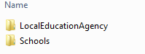
(Above is contents of the SchoolsAndLEA folder.)
Note: none of these parent containing folders may be named exactly “Students”, “Staff”, “Schools”, or “LocalEducationAgency” as that will lead to misclassification of images.

Prepare for Upload

Once the package of images is created, and organized as shown above, convert it to a zip file. Right click the parent containing folder -> Send to -> Compressed (zipped) folder.
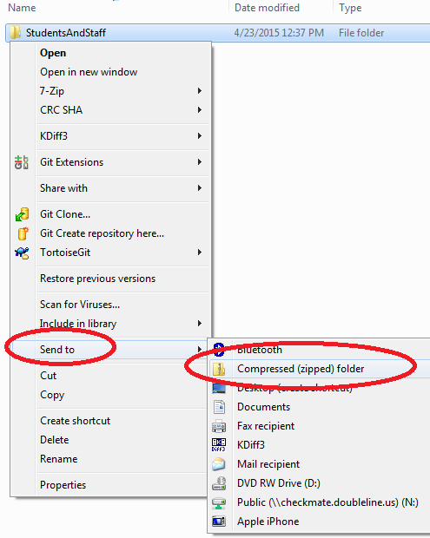

Upload Images

Only a dashboard system administrator has access to upload images. From the Dashboard’s Admin console, select the Photo Management tab.
To upload student and staff photos for a particular school, select that school from the dropdown in the top section. Then, click the ‘Choose File’ button, which will open a file browser modal dialog, allowing the user to find the zipped student and staff package (in the above example, StudentsAndStaff.zip.)
To upload school and local education agency photos for a particular local education agency, simply click the ‘Choose File’ button in the second section. This will open a file browser modal dialog, allowing the user to find the zipped school and local education agency package (in the above example, SchoolsAndLEA.zip.)
Once the user selects the file, the system will automatically upload the document. The screen will refresh and provide a status of the upload.
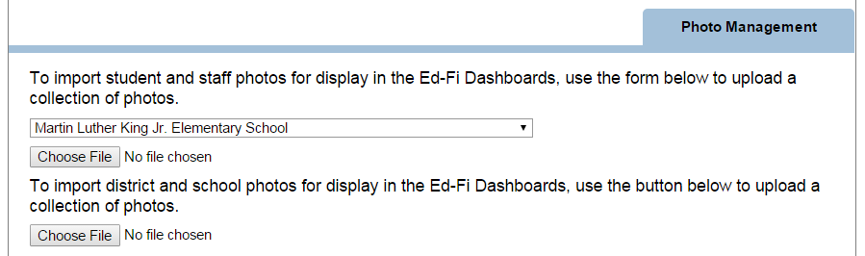
Note: If you would like to upload additional files, you can upload additional image packages following the same instructions. Uploading new images will not delete the old images, however if an image already exists the system will override the previous image.

Technical Notes

ID Lookup Tables
The USI and ID lookups are performed against the following tables:
Student - StudentSchoolInformation
Staff – StaffEducationOrgInformation
School – SchoolInformation
Local Education Agency – LocalEducationAgencyInformation
Student and staff lookups are determined based on a school ID for context, because student and staff images are specific to a school. School and LEA lookups, however, are determined using LEA ID for context.

IIS & Image Caching
As IIS will cache the images, resetting the IIS cache on the web application server is required for images to display. Please contact your infrastructure admin to perform this operation. This may be accomplished by running the iisreset command, or redeploying the application.

